



Brand Guidelines

V01 | JULY 2022

[**WWW.MCU.EDU.PH**](http://WWW.MCU.EDU.PH/)

**The Institution that Empowers and Transforms since 1904 is the legacy we share today—**

Bigger, Bolder and Brighter.

As students, alumni, faculty, staff, management and community partners, we continue to breathe life into the legacy of Manila Central University (MCU).Hence, we aim to create comprehensive guidance and standards that ensure all aspects of our refreshed brand are clear, and that tools are shared to help articulate, express and evaluate the brand in every aspect of our daily work.

Upholding and maintaining a strong brand image is critical to the continued success and growth of the university.

We graciously share the role and responsibility to constantly preserve MCU’s brand and integrity.

Presenting MCU in a consistent, professional and authentic way will reinforce the significance and distinction of our message and its creative visualization.

We respectfully request your strict compliance to these guidelines and standards. For clarifications and guidance on the brand usage and applications, or to request a file, please contact our communications

department at: communications@mcu. edu.ph

##### Contents

THE MCU BRAND

MASTER BRAND

VISUAL ELEMENTS APPLICATIONS TEAM SPIRIT

|  |  |  |  |  |  |  |  |  |
| --- | --- | --- | --- | --- | --- | --- | --- | --- |
| 04 **PURPOSE, VMV** | 11 | **OUR SEAL** | 53 | **PHOTOGRAPHY** | 65 | **WORKING ALL** | XX | **TEAM SPIRIT BRAND** |
| 05 **THE MCU BRAND** | 14 | **OUR LOGO** | 57 | **BRAND PATTERNS** |  | **TOGETHER** | XX | **UNIVERSITY MASCOT** |
| 06 **BRAND PROMISE** | 15 | **LOGO VERSIONS** | 61 | **GRAPHIC ELEMENTS** |  | **PRINT** | XX | **LOGO FORMATS** |
| 07 **OUR VOICE & TONE** | 16 | **LOGO FORMATS** |  |  |  | **DIGITAL** | XX | **WORDMARK FORMATS** |
| **OUR PERSONALITY** | 19 | **LOGO USAGE** |  |  |  | **SOCIAL MEDIA** | XX | **USAGE** |
| 08 **BRAND** | 23 | **BRAND COLORS** |  |  |  | **WEBSITE** | XX | **ATHLETIC TEAM** |
| **DIFFERENTIATOR** | 33 | **TYPOGRAPHY** |  |  |  | **MERCHANDISE** | XX | **NAMES** |
| 09 **BRAND MANIFESTO** | 42 | **SIGNATURE IDENTITIES** |  |  |  |  | XX | **ATHLETIC NUMBERS** |
|  | 44 | **COLLEGE SEALS** |  |  |  |  | XX | **APPLICATIONS** |



**Empower More People Through Innovative Education**

O U R P U R P O S E

**A Leading Filipino University Sharing Talents To The World**

O U R V I S I O N

**Nurture Transformative Learning Experiences**

O U R M I S S I O N

**Integrity Nurturing Prudence Resilience Perseverance**

O U R V A L U E S

 **4**

**Brand Promise**

Our value and our promise of excellence to

##### The MCU Brand

**Our Voice & Tone**

the MCU community --- Our students, Faculty, Parents, Alumni and all MCU stakeholders.

**Brand Differentiator**

Our Brand differentiator are the intangibles and unique attributes that support our brand promise and sets MCU apart from other

brands.

How we speak and conduct our communication — the purposeful and deliberate context of our correspondence, declaration and its delivery.

**Our Personality**

The set of attributes that reflects our identity, shapes our character and creates our connection across members of our community.

**Brand Manifesto**

A declaration of the fundamentals and core principles that encapsulates the MCU brand— what it stands for, its character, purpose & goals, and forward-driven actions to continuously innovate and sustain the brand’s aspirations.



**5**

BRAND P R O MISE



##### Transforming lives through Innovative Education

Through innovative education and a culture of quality, we have been

transforming our students into better versions of themselves uplifting the communities we serve while producing global citizens since 1904.

MCU’s rich history has always been driven by a pioneering and innovative spirit. True to our calling as a service-oriented university, we equip our students with innovative education balanced by a good values system and a greater sense of service.

**6**



OUR PER S O NALITY



#### Passionate Educators and Nurturers

Nurturing, sincere and authentic. We celebrate unity in diversity. We embrace differences with empathy and encouragement.

Innovative & Resourceful, we constantly seek to improve our ways and means of teaching, working, connecting and nurturing.

Spirited, bold, exciting, vibrant, young & contemporary but still rooted in our heritage and traditional values.

Fair & Honest, trustworthy, promotes integrity and perseveres in compassionate and meaningful interactions.



**7**

OUR VO ICE & TO NE



#### One Voice Made of Many

Our voice needs to embody and represent our community. The way we communicate and convey messages should reflect the values that we collectively uphold throughout MCU.

Our voice should humanize our brand and uplift our reputation. Our tone should be consistent, authentic,

and nurturing throughout all communication touch points.

Overall, how we look is just as important as how we speak.

Intelligent & Confident yet sincere and unassuming.

Empowering & Bold, but never arrogant.

Vibrant & Progressive, always optimistic and proactive.

Considerate & Nurturing, consistently welcoming, encouraging and empathetic.

We want to speak clearly, simply, and constantly authentic. Our tone and manner should enable meaningful engagement and spark excitement to our community.

**8**



BRAND DIF F ER ENT I ATO R



#### To Light, Spark, & Ignite.

We educate to inspire and transform. We empower our community to spark change for the better and ignite continuous growth for the next generations.

Trailblazer, forward-thinker, visionary leader that sparks a pioneering spirit.

Torch-Bearer & Advocates, Illuminating the way for future leaders and innovators from the Philippines to anywhere in the world.

We advocate for spirituality, humanity and sustainability. Trailblazing the way— to light, to spark, to ignite.



**9**





B R A N D M A N I F E S T O

We are Educators and Nurturers. We are entrusted to teach and transform learners to become dynamic and competent members of society. We equip minds with high-quality and values- based education. We guide students toward excellence, integrity, perseverance, and innovation.

We take responsibility in the continuous improvement and growth of our community by nurturing talents, knowledge, skills, character, and sense of service.

We are a family. We promote trust, confidence, and growth among members of our community. We are united in success and in challenges. We speak and react with high respect towards one another. We give high regard to the respective contribution each of us brings to our community and to the world. We strive at all times to follow the precepts and teachings of our Greatest Teacher, Healer, and Creator.

We are continuing a legacy that began in 1904, that education is both knowledge and character building. Today, we persevere to make possibilities happen and opportunities open.

We are Centralinos.

We are now Bigger, Bolder, Brighter.

**10**



##### Our University Seal

The MCU university seal is an essential part of our university’s rich heritage. It encompasses our humble beginnings, what we stand for and our journey towards our goals, aspirations and promising future.

Our seal is reserved for use primarily on official and formal communications. Yet, It may also be used on specific document/s with the objective to formally designate such document or digital message as “The Official MCU Communication/ Correspondence”.

**EXAMPLE APPLICATIONS**

Letterhead, Business Card, Envelopes, and other MCU official stationery.

Diplomas, Institutional Certificates, Special Awards, Medallions, Office of the President and other official University stamp of validation.

DO NOT:

Use the seal for any marketing or promotional marketing material. Instead, use the official MCU logo.

Inspired by Jose Rizal’s The Triumph of Science Over Death. This symbolizes the

University’s beginnings and heritage as the first Pharmacy school in the Philippines.



Torch of Knowledge and Sun rays represents brighter and more vibrant future for its students.

Caduceus Science Courses

Book & Quill Education Courses

Care Services Compassionate Service

Mortar Pharmacy as first college founded

Academic Freedom Strong foundation, Justice & Equality and Compassion

Mercury Fast Delivery of Service

Shield Enforces Trust and Security

Laurel wreath Prestige and Honor

Banner and Enclosure Solidarity and Science MCU Community and founding date

UNIV ER SITY SEAL

##### Formats & Variation

The versions of the MCU seal shown in this page are the only versions permitted for use. Do not modify the seal in any way.

**PRIMARY VARI ATION USAGE**

Official MCU Stationery and other stamp of validation as stated in the previous page.

**SECONDARY VARI ATION USAGE**

Only use these versions if the application is NOT a formal communication material such as: presentation folders, digital applications, non-official envelopes and other university collaterals.



**PRIMARY**

**TWO-COLOR**



**PRIMARY ONE-COLOR**

DO NOT:

Use the seal for any marketing or promotional marketing material. Use the official MCU logo instead.

For clarifications and guidance on the brand usage and applications, or to request a file, please contact our communications department at: [communications@mcu.edu.ph](mailto:communications@mcu.edu.ph)

**SECONDARY**

**ONE COLOR LIGHT**

**SECONDARY**

**GR AYSCALE**

Only use in Black and White Applications

**SECONDARY**

**REVERSE**

Only use in Purple background or dark background colors

UNIV ER SITY SEAL



##### Size

In order to maintain full legibility and preserve its integrity, never reproduce the seal at widths smaller than 1.25 inches (for print) or 250 pixels (for screen). There is no maximum size limit.

1.25” or 250px 1.25” or 250px

##### Clear Space Placement

Ensure that clear space is maintained around the seal for legibility and prominence.

Ensure there are no graphics or photos in its background or clear space area.

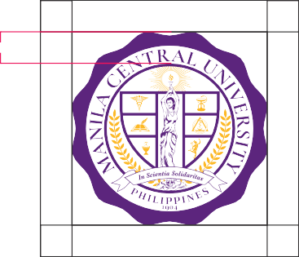

From the tip of the seal up to the enclosing container/circle, use its height as a measuring tool to help determine minimum clearance.

Only place the seal in these following allowed positions: Top Left, Top Center, Top Right and Bottom Right.

Only place the seal in vertically and horizontally aligned center for covers of an official MCU document/collateral.

##### Our Logo

Our logo plays an essential role in representing the University. It represents MCU brand at its highest level—- what we stand for, our goals and purpose as one institution and how we conduct and

compose our brand as a whole for internal and external communications.

Our logo instills every university touch point. It acts as a signature, an identifier and should always be, the most consistent component across our communications. In order to maintain consistency and brand recognition, simple guidelines must be followed at all times.

Our Logo is a simplified version of our University seal which its key elements such as the torch

of knowledge, the shield, laurel wreath and the founding date are all derived from. While each element represents distinct symbolisms, as a whole it upholds and advocates the core purpose and manifestation of the MCU brand.

**PRIMARY**

**INSTITUTIONAL LOGO**

L OGOMARK

L O G OT Y PE

**SECONDARY MINIMALIST LOGO**

L OGOMARK

L O G OT Y PE

DO NOT:

Use the seal for any marketing or promotional marketing material. Instead, use the official MCU logo.

To best represent the MCU brand across any communication piece to its diverse audience, we have two versions of the logo for usage --- Institutional Logo and Minimalist Logo.

Guidance and recommendations of its usage is detailed on the next page.

##### Logo Versions and Applications



As a general rule, use the primary institutional logo whenever possible.

|  |  |  |
| --- | --- | --- |
| Institutional Letterhead, Envelopes, Stationary | Required | No |
| Business card, post card, bookmarks, notepads | Yes | Yes, except for Official Business Card |
| Awards, Certificates, and other Recognition Piece | Required | No |
| Pairing with other MCU departments or colleges | Required | No |
| Pairing with outside institutions | Required | No |
| Pairing with Team Spirit Logo or other Athletics Logo | Yes | Yes |
| Digital Power Point Templates Cover | Required | Yes, except for Official PPT template |
| Digital Power Point Templates Inner Pages | Yes | Yes |
| Social Media Profile Pictures | Required | No |
| Social Media Posts and Advertisements | Yes | Yes, except for Official and/or Formal University statements/memo |
| Website Main Heading and Banners | Required | No |
| Website Internal banners and images | Yes | Yes |
| System Landing Pages | Required | No |
| Internal School Premises Signages and Wayfinders | Yes | Yes |
| External Communications | Yes | Yes |
| Official School Profile | Required | No |
| College Brochures and Marketing Materials | Required | No |
| University Newsletter Nameplate | Required | No |
| Posters and Banners | Yes | Yes, except for Official and/or Formal University statements/memo |
| Merchandise | Yes | Yes |
| Video Covers, Openers, Outros | Required | No |
| Video Lower thirds element / Using logomark only | No | Yes |
| Using logomark or its elements as part of a communication piece design | No | Yes |
| Using the logomark only | No | Yes, but pair with University name or web URL |

However, understanding that some communication pieces along with its messaging may be more vibrant, spirited and relaxed that target a

younger audience--- you may use the secondary or minimalist logo instead to provide a more simplified and dynamic overall messaging. This is to also ensure that the primary institutional logo will preserve its formal communication/ corresponding image and style.

Another quick guidance - should the applications are intended for “formal use”, kindly ensure to use/ apply the primary institutional logo.

Otherwise, for informal applications or communications, you may use the

minimalist logo. Either way, please still be guided with its proper usage for both logos.

For clarifications and guidance on the brand usage and applications, or to request a file, please contact

our communications department at: [communications@mcu.edu.ph](mailto:communications@mcu.edu.ph)

LO GO F O R M AT S



|  |  |  |
| --- | --- | --- |
|  | **Horizontal Orientation** Primary  All usage | **2 inches | 300 pixels** |
|  | **Stacked Format**  Primary All usage | **1 inch | 125 pixels** |
|  | **Compact Format**  Use only if the legibility of the horizontal and stacked  formats are not visibly clear or the material requires a more compact format | **1.5 inches | 200 pixels** |
|  | **Round Format**  Use only if the medium is in round format. Ex. Round pins, CD Covers, Coasters, circular mouse pads, circular stickers or other round merchandise or materials. Cannot be use in screen formats | **1.5 inches** |

##### Institutional Logo

The table on the right shows the hierarchy of usage or choosing the most suitable logo for any creative communications and applications.

2nd column - usage

3rd column - minimum sizes for both print and screen resolution

LO GO F O R M AT S



|  |  |  |
| --- | --- | --- |
|  | **Horizontal Orientation**  Primary  All permitted usage | **1.25 inches | 200 pixels** |
|  | **Stacked Format**  Primary  All permitted usage | **.75 inches | 110 pixels** |
|  | **Compact Format**  Secondary  All permitted usage | **1.25 inches | 200 pixels** |
|  | **Horizontal Full Format**  Use in long and horizontal environments such as footers, ID lanyard, perimeter stickers, banners with restricted height | **1.75 inches | 250 pixels** |
|  | **Icon Only**  Only use if paired with an identifier such as the University Name or website URL address | **.5 inches | 80 pixels** |

##### Minimalist Logo

The table on the right shows the hierarchy of usage or choosing the most suitable logo for any creative communications and applications.



2nd column - usage

3rd column - minimum sizes for both print and screen resolution



LO GO F O R M AT S

##### Revserse Color



Both the Institutional and minimalist logo are available in reverse color only to be used in purple shades background, dark background or images and in some other special cases.



LO GO US AGE

##### Clear Space

Should be maintained around the logo for legibility and prominence. Photos and graphics set as background are allowed provided that the logo is readable and unobstructed. Brand Colors should also not blend or overpower by the colors of the photos and graphics used.

Use the distance/measurement from the tip of the flame to the tip of the shield to create minimum clear space measuring guide to be used in all sides.



##### Placement and Sizing

Logo must only be placed in the following areas/positions: Upper portion: Left, Center & Right. Lower Portion: Left, Center & Right.



Only use center-aligned logo in official MCU documents, collaterals, formal applications and special cases such as merchandise.

Also shown are recommendations for logo sizing and its relation with the size of the medium and its surrounding negative space to provide a good visual balance and weight.



LO GO US AGE

Review some examples for guidance on correct and incorrect use of our Logo.



Incorrect placement of the logo

Using the Institutional logomark is not allowed as a stand-alone

Although the placement of the logo is correct, there is not enough clear space degrading the logo visibility and obstructing the key image as well.

LO GO US AGE

Review some examples for guidance on correct and incorrect use of our Logo.



The logo is not visible and difficult to read against dark backgrounds. Use the reverse version instead for legibility.

Using the minimalist logo without an identifier is incorrect.

Do not alter or change the color of the logo.

LO GO US AGE

Review some examples for guidance on correct and incorrect use of our Logo.

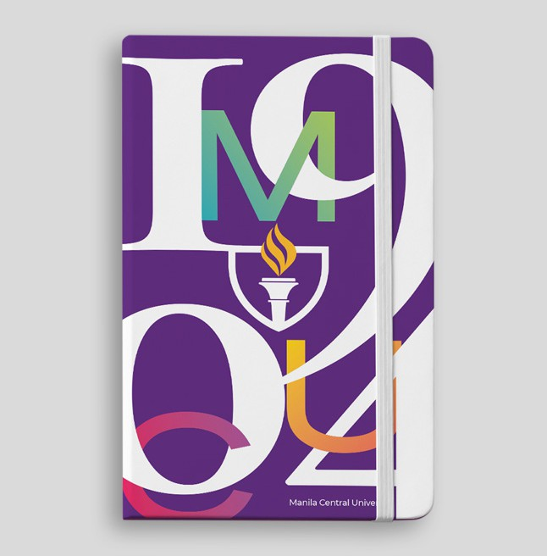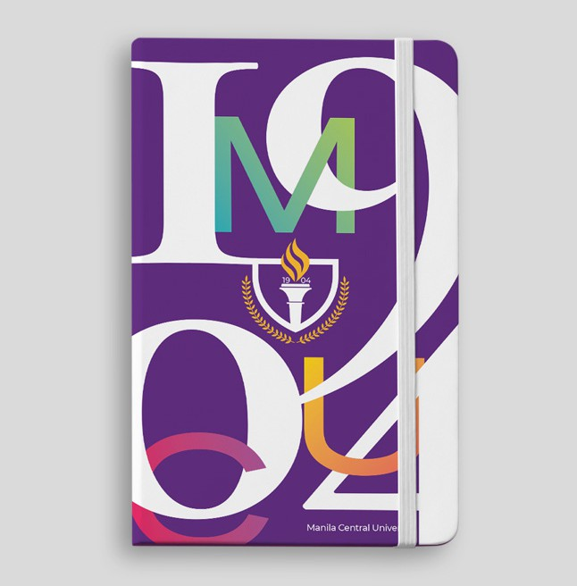



Do not use a vertically rotated logo. Choose the logo version that best fit the composition as per stated in the guideline.

Do not use the Institutional logomark as part of a design composition.

The minimalist logomark is allowed with guidance and approval of the communications department.

Do not use drop shadows, strokes, glows, or any other visual effects on the logo. You may brighten the surrounding area or recompose your artwork for better brand visibility.

##### Brand Colors



Beyond our logo, color is the most recognizable aspect of our brand identity.

**PR IMAR Y CO LO R S**

**ACCENT CO LO R S**

The MCU Brand Colors were obtained from the color spectrum of a flame. The flame and its colors represents the University’s diverse community, vibrant culture and environment, distinctive values, pursuit of innovation, and burning passion of the institution to provide quality education, transformation and excellence.

Applying colors appropriately is an essential part to ensure our communication materials reflect a cohesive MCU brand image and visual story.



**23**

BRAND CO LO R S

The MCU colors have two (2) layers: primary and secondary colors, each with its own subgrouping of colors --- Brights, Neutrals, and Darks. When using color builds, always use the color values listed here. They were adjusted for best reproduction in print and on screen use.

The colors are named for familiarization and easier identification when co-working a material within a group or outside suppliers.

**Primary Colors Secondary / Accent Colors**

**Brights**

**MCU**

**Purple &**

**Gold**

**Darks**

**Neutrals**

**Vibrants**

|  |  |  |  |  |  |  |
| --- | --- | --- | --- | --- | --- | --- |
| Gold Burst | Purple Haze | Oat | Sage | Mist | Rose | Vintage |
| Gold Ignite | Purple Sunset |
| **Heritage Gold** | **Heritage Purple** | **Sunlit Yellow** | **Fresh Green** | **Calm Blue** | **Blazing Pink** | **Flame Red** |
| Gold Spark | Purple Panther | Honey | Forest | Stone | Crimson | Rust |
| Gold Medallion | Purple Midnight |

**Darks**

PR IMAR Y CO LO R S

**Gold Ignite**

Our primary colors represent MCU at the highest level and should be present in all communications whenever possible.

**Gold Burst**

Apart from the color white, our primary colors should be more dominant than the secondary or accent colors.

C | 000 M | 025 Y | 100 K | 000

R | 253 G | 193 B | 049

C | 000 M | 013 Y | 100 K | 000

R | 255 G | 214 B | 046

#ffd62e

#fdc131

##### Heritage Gold

**Gold Medallion**

**Gold Spark**

C | 000 M | 030 Y | 094 K | 000

R | 255 G | 183 B | 054

C | 000 M | 034 Y | 100 K | 018

R | 210 G | 149 B | 040 #d29528

C | 004 M | 038 Y | 100 K | 000

R | 240 G | 167 B | 051 #f0a733

#ffb736

##### Heritage Purple

**Purple Sunset**

**Purple Haze**

C | 075 M | 100 Y | 005 K | 012

R | 092 G | 041 B | 124 #5c297c

C | 070 M | 100 Y | 020 K | 010

R | 104 G | 038 B | 114

#682672

C | 070 M | 100 Y | 013 K | 000

R | 113 G | 044 B | 131 #712c83

**Purple Midnight**

**Purple Panther**

C | 075 M | 100 Y | 000 K | 064

C | 075 M | 100 Y | 005 K | 035

R | 073 G | 020 B | 100

#491464

R | 046 G | 000 B | 070 #2e0046

SE CO N DA R Y

NEUT RAL CO LO R S

Our neutral colors add balance and warmth to the larger MCU brand colors. It provides a sense of calmness, tranquility and composure. Note that some neutral colors may not be appropriate/applicable for use as text colors.

**Oat**

**Sage**

**Mist**

**Rose**

**Vintage**

C | 000 M | 005 Y | 025 K | 010

R | 232 G | 217 B | 181

#e8d9b5

C | 030 M | 012 Y | 045 K | 000

R | 183 G | 198 B | 156

#b7c69c

C | 030 M | 010 Y | 020 K | 000

R | 179 G | 204 B | 200

#b3ccc8

C | 015 M | 045 Y | 035 K | 000

R | 214 G | 152 B | 147 #d69893

C | 018 M | 061 Y | 065 K | 000

R | 208 G | 123 B | 97 #d07b61

**26**



SE CO N DA R Y

V IBRANT CO LO R S

The vibrant secondary colors brings intensity, youthfulness, excitement and energy to MCU brand colors. Use the vibrants colors sparingly. It should only be use as accents only and not as the dominant or main color in a composition. It should never be used for formal and ‘official’ communication materials. They also never be use in text or headlines.

**Sunlit Yellow**

**Fresh Green**

**Calm Blue**

**Blazing**

**Pink**

**Flame**

**Red**

C | 000 M | 013 Y | 100 K | 000

R | 255 G | 216 B | 000

#ffd800

C | 033 M | 000 Y | 090 K | 000

R | 182 G | 213 B | 073 #b6d549

C | 076 M | 011 Y | 023 K | 000

R | 000 G | 170 B | 191

#00aabf

C | 000 M | 100 Y | 050 K | 000

R | 237 G | 020 B | 091

#ed145b

C | 000 M | 100 Y | 100 K | 000

R | 237 G | 028 B | 036

#ed1c24



**27**

SE CO N DA R Y

DAR K CO LO R S

MCU’s dark secondary colors add sophistication and contrast to our communication materials.

**Honey**

**Forest**

**Stone**

**Crimson**

**Rust**

C | 004 M | 038 Y | 100 K | 000

R | 140 G | 167 B | 031

#f0a71f

C | 045 M | 000 Y | 090 K | 025

R | 118 G | 161 B | 061 #76a13d

C | 016 M | 015 Y | 020 K | 040

R | 065 G | 119 B | 132

#417784

C | 013 M | 100 Y | 036 K | 037

R | 147 G | 001 B | 071

#930147

C | 000 M | 090 Y | 095 K | 050

R | 140 G | 032 B | 009 #8c2009

**28**



##### Gradient Palette

The gradient palette is intended to assist in adding depth and subtle color variation without overpowering the design. Though you may create gradient colors through combination of the MCU brand colors, it is still best to consult and seek approval from the communications and marketing department. Below are some examples.



PURPLE MIDNIGHT

+

PURPLE HAZE



STONE

+

HERITAGE PURPLE



PURPLE SUNSET

+

MIST



FOREST

+

SUNLIT YELLOW



FRESH GREEN

+

CALM BLUE



HERITAGE GOLD

+

FLAME RED

+

HERITAGE PURPLE



HERITAGE PURPLE

+

BLAZING PINK



FLAME RED

+

GOLD BURST



PURPLE PANTHER

+

FLAME RED



PURPLE PANTHER

+

CRIMSON



GOLD IGNITE

+

ROSE



MIST

+

ROSE



MIST

+

SAGE

+

GOLD BURST



VINTAGE

+

MIST



SAGE

+

OAT

**29** 

##### Using Colors



F O R MAL

CA S UA L

It is imperative to maintain a sense of hierarchy, balance and harmony when using the MCU brand colors. Our brand color system is designed to be flexible and adaptable, but exercises restraint. Distinct and exciting color palettes can be created from as few as three to five color

combinations already including white and primary colors.

It is important to use colors based on the message or tone of the communication material. Please be guided on the mood each color conveys to assist you in determining the appropriate color to be use. Colors can range from formal to casual and from subtle to vibrant.

V IBRANT

SUB T LE

Although this color guide are nearly fully flooded with color, we recommend to utilize and maximize the color ‘white’. The white or negative space plays a key role in our visual identity. It serves as a pause and can assist in drawing focus on the subject or key elements of your communication piece.

Always balance color, typography and graphic elements with generous amounts of white space or negative space.

**30**



**65/35**



##### Color-Use

**Ratio**

In creating compositions and artworks, the primary colors and secondary/accent colors should follow a color composition ratio below:

**65% or more Primary Colors**

**and no more than 35% of secondary/ accent colors**



The Primary Colors should be the dominant and most visible color element/s

Please note: Negative space or the color white is considered as our Primary Color. Use generously as needed.

(refer in sample applications for reference)



**31**

##### Color Samples



 **32**





##### Typography

When used effectively, our typography becomes a powerful brand tool that conveys and adds visual meaning to what is communicated. MCU’s selected typography reflects our brand voice and personality - communicates clearly, cleanly, simply and is flexible in a wide range of circumstances/ conditions.

Our typography palette contains Sans-Serif, Serif, calligraphy fonts and selected sports or team-spirit related font types.

Suggested pairings and usage of these fonts are guided in the next few pages.



**33**

SER IF

B A SK ER V ILLE

**Centralino**

Aa *Aa* **Aa *Aa* Aa *Aa***

**Best use for:**

Main Headings for casual to formal communication

**Other recommended use:**

Regular Headings | Sub-Headings

**Recommended Leading and Tracking (headings)** Subtract 5-10 pts from your preferred font size. Ex: if the font size is 50pt your leading should be between 40-45pt

**Leading and Tracking (subhead & paragraphs)**

Regular

Italic

Semibold

Semibold Italic

Bold

Bold Italic

Add 0-6 pts from your preferred text size. Ex: if the font size is 12pt your leading should be between 12-18pt

Lorem ipsum dolor sit amet, consectetur adipiscing elit, sed do eiusmod tempor incididunt ut labore et dolore magna aliqua. Ut enim ad minim veniam, quis nostrud exercitation ullamco laboris nisi ut aliquip ex ea commodo consequat. Duis aute irure dolor in reprehenderit in voluptate velit esse cillum dolore eu fugiat nulla pariatur. Sunt in culpa qui officia deserunt mollit anim id est laborum

ADDIN GTO N CF

# Centralino

Aa Aa **Aa Aa Aa** Aa

Tracking: 0pt

**Best paired with**

Montserrat for paragraphs or sub texts

**Best use for:**

Headings and sub-texts for formal communications

**Other recommended use:**

Sub-Headings

**Leading and Tracking (headings)**

Subtract 5-10 pts from your preferred text size. Ex: if the font size is 50pt your leading should be between 40-45pt

Regular

Medium

Demibold

Bold

Extra Bold

Light

**Leading and Tracking (subhead & paragraphs)**

Add 0-6 pts from your preferred text size. Ex: if the font size is 12pt your leading should be between 12-18pt

Lorem ipsum dolor sit amet, consectetur adipiscing elit, sed do eiusmod tempor incididunt ut labore et dolore magna aliqua. Ut enim ad minim veniam, quis nostrud exercitation ullamco laboris nisi ut aliquip ex ea commodo consequat. Duis aute irure dolor in reprehenderit in voluptate velit esse cillum dolore eu fugiat nulla pariatur. Sunt in culpa qui officia deserunt mollit anim id est laborum

Tracking: 0pt

**Best paired with**

Kross Neue Grotesk for paragraphs or sub texts

S ANS-SER IF

MO NT SER R AT

# Centralino

Aa Aa **Aa Aa Aa** Aa

**Best use for:**

Main Headings for casual to semi-formal communication

**Other recommended use:**

Regular Headings | Sub-Headings | Paragraphs

**Recommended Leading and Tracking (headings)** Subtract 3-10 pts from your preferred text size. Ex: if the text size is 50pt your leading should be between 40-47pt

**Leading and Tracking (subhead & paragraphs)**

Regular

Medium

Semibold

Bold

Extrabold

Light

Add 0-6 pts from your preferred text size. Ex: if the text size is 12pt your leading should be between 12-18pt

Lorem ipsum dolor sit amet, consectetur adipiscing elit, sed do eiusmod tempor incididunt ut labore et dolore magna aliqua. Ut enim ad minim veniam, quis nostrud exercitation ullamco laboris nisi ut aliquip ex ea commodo consequat. Duis aute irure dolor in reprehenderit in voluptate velit esse cillum dolore eu fugiat nulla pariatur. Sunt in culpa qui officia deserunt mollit anim id est laborum

K R OSS NEUE GR OT E SK

# Centralino

Aa Aa **Aa** Aa Aa Aa

Tracking: -10pt

**Best paired with**

Any of our selected typography pallete

**Best use for:**

Headings and sub-texts for casual communications UPPERCASE Headings and Sub-headings

**Other recommended use:**

Paragraphs

**Leading and Tracking (headings)**

Subtract 3-10 pts from your preferred text size. Ex: if the text size is 50pt your leading should be between 40-47pt

Regular

Book

Bold

Heavy

Light

Thin

**Leading and Tracking (subhead & paragraphs)**

Add 0-6 pts from your preferred text size. Ex: if the text size is 12pt your leading should be between 12-18pt

Lorem ipsum dolor sit amet, consectetur adipiscing elit, sed do eiusmod tempor incididunt

ut labore et dolore magna aliqua. Ut enim ad minim veniam, quis nostrud exercitation ullamco laboris nisi ut aliquip ex ea commodo consequat. Duis aute irure dolor in reprehenderit in voluptate velit esse cillum dolore eu fugiat nulla pariatur. Sunt in culpa qui officia deserunt mollit anim id est laborum

Tracking: 0pt (regular) 150-200pt (uppercase)

**Best paired with**

Any of our selected typography pallete

OT HER F O NT TY PE S

HAND

WR ITT EN

BA RC E LO NY

*Proud Centralino*

*Lorem ipsum dolor sit amet, consectetur cing elit, sed do eiusmod tempor incididunt ut labore et dolore magna aliquaseqatur.*

**Best use for:** Casual and Vibrant Communications

T EAM SPIR IT

S AEK ANA

B AT TA MS

Centralino

**Best use for:**

Team Spirit and Athletics Communications

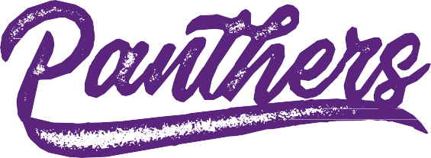VAR SITY

MCU TRAILBLAZERS

**Best use for:**

Team Spirit and Athletics Communications

**Best use for:**

DE VA NT MEDIUM

## MCU BLAZING PANTHERS

Team Spirit and Athletics

##### Using Type

Choosing a font should depend on the intended usage, audience and type of messaging. Use the grid on the right to

Addington CF Medium

F O R MAL

**Addington CF**

help determine which main fonts best suit your communication piece.

Alternate

If our Serif and Sans-Serif font is not readily available, you may use Times New Roman and Century Gothic for Headings while Arial for paragraphs as alternate fonts.

Centralino

Times New Roman

###### Centralino

Century Gothic Bold

Lorem ipsum dolor sit amet, consectetur adipiscing elit, sed do eiusmod tempor incididunt ut labore et dolore magna aliqua.

**KR OSS NEUE B O LD UPPER CA SE**

Montserrat Light

**Montserrat Semibold**

SUB T LE

Montserrat Medium

Baskerville Semibold

Montserrat Semibold

**Medium**

**Baskerville Bold**

**Montserrat Bold**

V IBRANT

**Baskerville Semibold**

Arial Regular

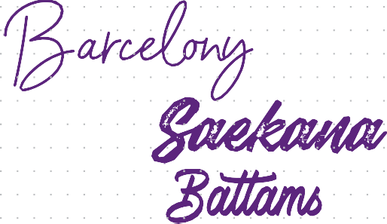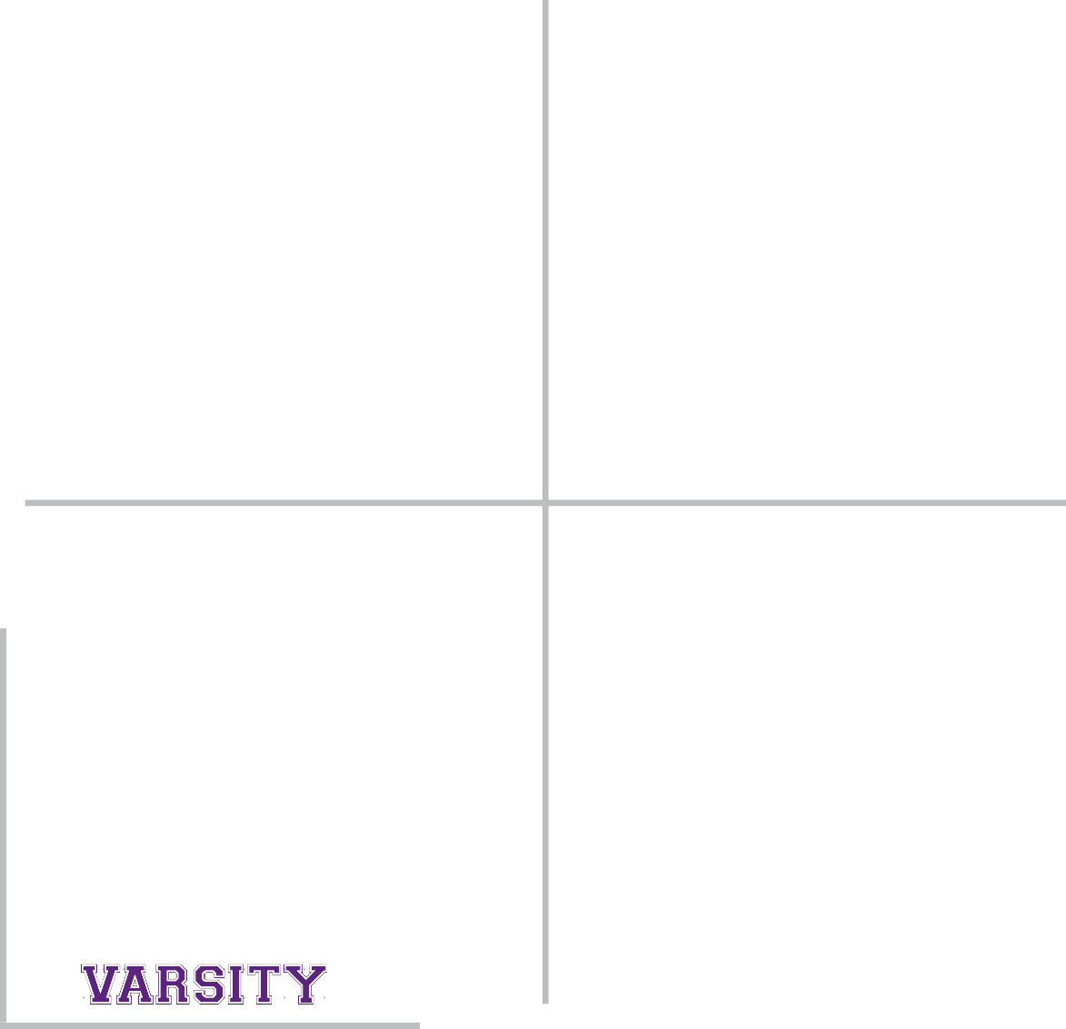

CA S UA L

S AMPLE F O NT PAIR INGS

## Lorem Ipsum Dolor Sit Amet

Vivamus viverra accumsan lorem, a mollis est vehicula eget mauris lobortis condimentum

MAE CENA S CO N VA LLIS NUNC

Lorem ipsum dolor sit amet, consectetur adipiscing elit, sed do eiusmod tempor incididunt ut labore et dolore magna aliqua. Ut enim ad minim veniam, quis nostrud exercitation ullamco laboris nisi ut aliquip ex ea comcill anim

**Ut enim ad minim veniam, quis nostrud exercitation ullamco laboris nisi ut aliquip ex ea comcill anim**

F O R MAL + SUB T LE

**HEADING**

Addington Medium Size: 60 pt.

Leading: 50 pt. | Tracking: 0 pt.

**SUBHEADING**

Montserrat Light Size: 26 pt.

Leading: 26 pt. | Tracking: 0 pt.

**LEAD-IN**

Kross Neue Grotesk Bold Uppercase Size: 15 pt.

Leading: 16 pt. | Tracking: 200 pt.

**BODY**

Baskerville Regular Size: 12 pt.

Leading: 16 pt. | Tracking: 0 pt.

**CALL OUT**

Baskerville Semibold Size: 10 pt.

Leading: 11 pt. | Tracking: 0 pt.

S AMPLE F O NT PAIR INGS

**Lorem Ipsum Dolor Sit**

Vivamus viverra accumsan lorem, a mollis est vehicula eget mauris lobortis condimentum

Maecenas convallis nunc

Lorem ipsum dolor sit amet, consectetur adipiscing elit, sed do eiusmod tempor incididunt ut labore et dolore magna aliqua. Ut enim ad minim veniam, quis nostrud exercitation ullamco laboris nisi ut aliquip ex ea comcill anim

**Ut enim ad minim veniam, quis nostrud exercitation ullamco laboris nisi ut aliquip ex ea comcill anim**

CA SU AL + V IBRANT

**HEADING**

Montserrat Bold Size: 53 pt.

Leading: 48 pt. | Tracking: 0 pt.

**SUBHEADING**

Montserrat Light Size: 26 pt.

Leading: 26 pt. | Tracking: 0 pt.

**LEAD-IN**

Baskerville Semibold Size: 28 pt.

Leading: 28 pt. | Tracking: 0 pt.

**BODY**

Montserrat Medium Size: 11 pt.

Leading: 15 pt. | Tracking: 0 pt.

**CALL OUT**

Montserrat Bold Size: 9 pt.

Leading: 13 pt. | Tracking: 0 pt.

S AMPLE F O NT PAIR INGS

### Lorem Ipsum Dolor Sit

Vivamus viverra accumsan lorem, a mollis est vehicula eget mauris lobortis condimentum

MAE CENA S CO N VA LLIS NUNC

Lorem ipsum dolor sit amet, consectetur adipiscing elit, sed do eiusmod tempor incididunt ut labore et dolore magna aliqua. Ut enim ad minim veniam, quis nostrud exercitation ullamco laboris nisi ut aliquip ex ea comcill anim

**Ut enim ad minim veniam, quis nostrud exercitation ullamco laboris nisi ut aliquip ex ea comcill anim**

CA SU AL + SUB T LE

**HEADING**

Montserrat Semibold Size: 56 pt.

Leading: 51 pt. | Tracking: 0 pt.

**SUBHEADING**

Baskerville Regular Size: 30 pt.

Leading: 25 pt. | Tracking: 0 pt.

**LEAD-IN**

Kross Neue Grotesk Bold Uppercase Size: 15 pt.

Leading: 16 pt. | Tracking: 200 pt.

**BODY**

Kross Neue Grotesk Size: 11 pt.

Leading: 15 pt. | Tracking: 0 pt.

**CALL OUT**

Montserrat Smibold Size: 9 pt.

Leading: 13 pt. | Tracking: 0 pt.

S AMPLE F O NT PAIR INGS

### Lorem Ipsum Dolor Sit

Vivamus viverra accumsan lorem, a mollis est vehicula eget mauris lobortis condimentum

***Maecenas convallis nunc***

Lorem ipsum dolor sit amet, consectetur adipiscing elit, sed do eiusmod tempor incididunt ut labore et dolore magna aliqua. Ut enim ad minim veniam, quis nostrud exercitation ullamco laboris nisi ut aliquip ex ea comcill anim

**Ut enim ad minim veniam, quis nostrud exercitation ullamco laboris nisi ut aliquip ex ea comcill anim**

F O R MAL + V IBRANT

**HEADING**

Baskerville Semibold Size: 56 pt.

Leading: 51 pt. | Tracking: 0 pt.

**SUBHEADING**

Monterrat Regular Size: 26 pt.

Leading: 29 pt. | Tracking: 0 pt.

**LEAD-IN**

Baskerville Bold Italic Size: 31 pt.

Leading: 28 pt. | Tracking: 0 pt.

**BODY**

Montserrat Medium Size: 11 pt.

Leading: 15 pt. | Tracking: 0 pt.

**CALL OUT**

Addington CF Demi Bold Size: 11 pt.

Leading: 14 pt. | Tracking: 0 pt.

##### Signature Identities

Our Signature Identities are designed as lock-ups with the minimalist logomark.

Our signature identites can be created with specific guidelines as shown below. Please consult and seek approval with the Communications and Marketing Department prior usage.

1. Use half of the distance from the tip of the flame to the tip of the shield to create minimum clear space and the gap between the logomark and name.
2. Font type and specifications: please refer below.
3. To determine the maximum font widtht: Use the size of the logomark and make three (3) horizontal copies without gutter space. Maximize the space. Move the word to the next line should it exceed the space.
4. To determine the maximum font height: Use the base of the torch and maximize the vertical space. Ensure that the first line and second line are at the edges of the guidelines.

Colleges & Academics Marks

X Clear Space X Max Width X Max Height

Montserrat Medium | Size: 55 pt. | Leading: 50 pt. | Tracking: -10 pt.

**Font Type:**

Montserrat Medium

**Leading and Tracking:**

Subtract 5-10 pts from your preferred font size. Ex: if the font size is 50pt your leading should be between 40-45pt



Alternate College Mark



**You may use this version if a MCU identifier is not present in a communication medium.**

Institute of Education

Basic Education Department



Departments



/Offices

**Font Type:**

Addington CF Medium

**Leading and Tracking:**

Subtract 5-10 pts from your preferred font size. Ex: if the font size is 50pt your leading should be between 40-45pt





##### College Seals Mark & Colors

College Seal:

Use as primary identity and for any type of formal and informal applications

College Marks:

Use only for informal applications.

For clarifications and guidance on the brand usage and applications, or to request a file, please contact our communications department at: [communications@mcu.edu.ph](mailto:communications@mcu.edu.ph)

**44**



SCHOOL OF BUSINESS & MANAGEMENT BASIC EDUCATION DE PARTMENT





Colors:

Minimum Sizes:

Colors:

Minimum Sizes:

Heritage Colors & Gold Ignite

1” or 200px

1.25” or 250px

Heritage Colors & Calm Blue

1” or 200px

1.25” or 250px





COLLEGE OF ARTS & SCIENCES COLLEGE OF DENTISTRY





College of Arts & Sciences

College of Dentistry

Colors:

Minimum Sizes:

Colors:

Minimum Sizes:

Heritage Colors & Stone

1” or 200px

1.25” or 250px

Heritage Colors & Blazing Pink

1” or 200px

1.25” or 250px





College of

Sciences

Arts &

College of Dentistry

COLLEGE OF MEDICAL TECHNOLOGY COLLEGE OF PHARMACY



College of Pharmacy

Colors:



Minimum Sizes:

Colors:

Minimum Sizes:

Heritage Colors & Crimson

1” or 200px

1.25” or 250px

Heritage Colors & Sage

1” or 200px

1.25” or 250px





College of

Pharmacy

COLLEGE OF OPTOMETRY COLLEGE OF NURSING



College of Optometry

Colors:



Minimum Sizes:

Colors:

Minimum Sizes:

Heritage Colors & Vintage

1” or 200px

1.25” or 250px

Heritage Colors & Honey

1” or 200px

1.25” or 250px





COLLEGE OF MEDICINE COLLEGE OF PHYSICAL THERAPY



College of Medicine

College of Physical Therapy

Colors:



Minimum Sizes:

Colors:

Minimum Sizes:

Heritage Colors & Forest

1” or 200px

1.25” or 250px

Heritage Purple & Rose

1” or 200px

1.25” or 250px





College of Physical Therapy

INSTITUTE OF EDUCATION GRADUATE EDUCATION & LIFE LONG LEARNING CENTER



**2022**



**2022**





Colors:

Minimum Sizes:

Colors:

Minimum Sizes:

Heritage Colors & Mist



**2022**

1” or 200px

1.25” or 250px

Heritage Colors & Gold Medallion

1” or 200px

1.25” or 250px





N ATIONAL SERVICE TRAINING PROGRAM

##### Placement and Sizing

Signature Identites, College marks and seals must only



be placed in the following areas/ positions:

Primary Two-color



Secondary Two-color

Colors:

Heritage Colors & White

Primary One-color



Secondary One-color

Minimum Sizes: 1” or 200px

Upper portion: Left & Right.

Lower Portion: Left & Right.

Also shown are recommendations for sizing and its relation with the size of the medium and its surrounding negative space to provide a good visual balance and weight.

##### Sample Usage

For Pairings with the University Seal, or other logos/marks, please follow the positioning and placement below.

General Rule:

If using the university seal, pair with the college mark. If using the College Seal, pair with the university logo

College Mark: If a MCU identifier is not present in your communication medium, you may use the alternate college mark/signature identity





**Manila Central University College of Arts & Sciences**

+63 2 8364-56-23 | [cas@mcu.edu.ph](mailto:cas@mcu.edu.ph)



EDSA, Caloocan City 1400

+63 2 8364-10-71 to 78 [**www.mcu.edu.ph**](http://www.mcu.edu.ph/)

[info@mcu.edu.ph](mailto:info@mcu.edu.ph)



College of Nursing

##### Photography & Art Direction

Photography and use of images are essential tools to tell our unique story. It showcases our diverse & vibrant

community. Our visual story should connect with people in a way that demonstrates our brand personality, tone, our aspirations and what we stand for.

**Our imagery should capture our community’s energy & enthusiasm, boldness & empowerment. It should be dynamic and impactful, shows warmth and sincerity, always vibrant and never dull.**





**53**

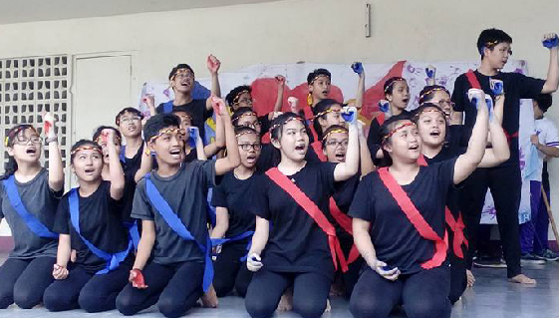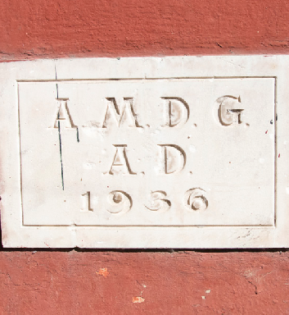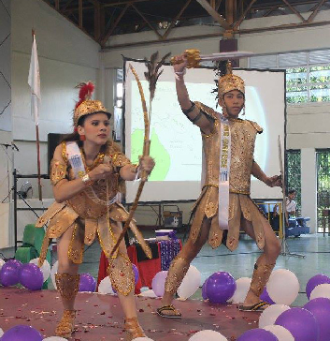

Our general approach to photography is to capture candid, intimate and joyful moments across our campus that reflect the stories

of Centralinos and our community.

**54**



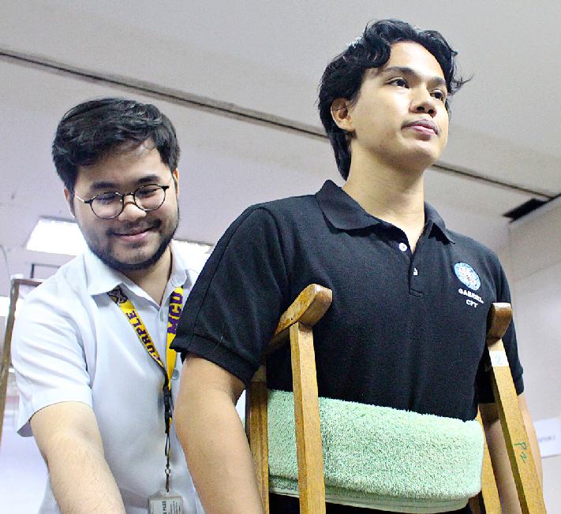

Our photography style and art direction should be inspiring, dynamic, natural.

Use natural or ambient light as much as possible. Avoid using camera flash/ or light positioned directly in front of your subject.



**55**



Color Correction: Veer away from overly photoshopped photos --- cinematic feels, filters, exceedingly color correction, addition of artificial light, vignettes and leaks.

Our photos should always feel organic, sincere, authentic and show its true vibrant colors.

**56**



##### Brand Patterns

Our distinct series of brand patterns complement our brand structure and enhanced its visual language. Inspired by elements of our seal, logo and culture, they express both our tone and personality --- vibrant, spirited, innovative and empowering.

We have four (4) available patterns for use in our documents and creatives. Patterns should be used selectively and without visual conflict. They should add visual impact to your layout and reinforce the brand in a subtle way.

Should always be used/applied with caution, patterns should only enhance and

should never take away the objective and message of the communication piece.

For clarifications and guidance on the brand usage and applications, or to request

**Contact Communications & Marketing at** [**communications@mcu.edu.ph**](mailto:communications@mcu.edu.ph)

a file, please contact our communications department at: [communications@mcu.edu.ph](mailto:communications@mcu.edu.ph)





**57**

BRAND PATT ER N

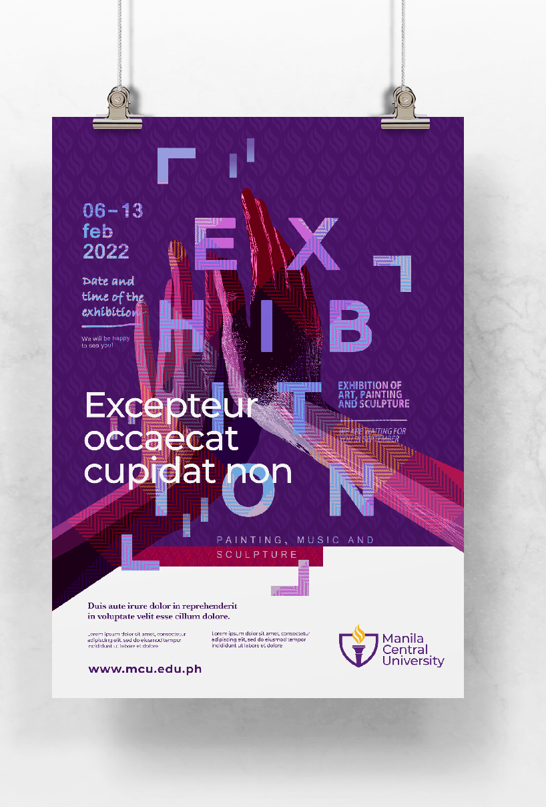

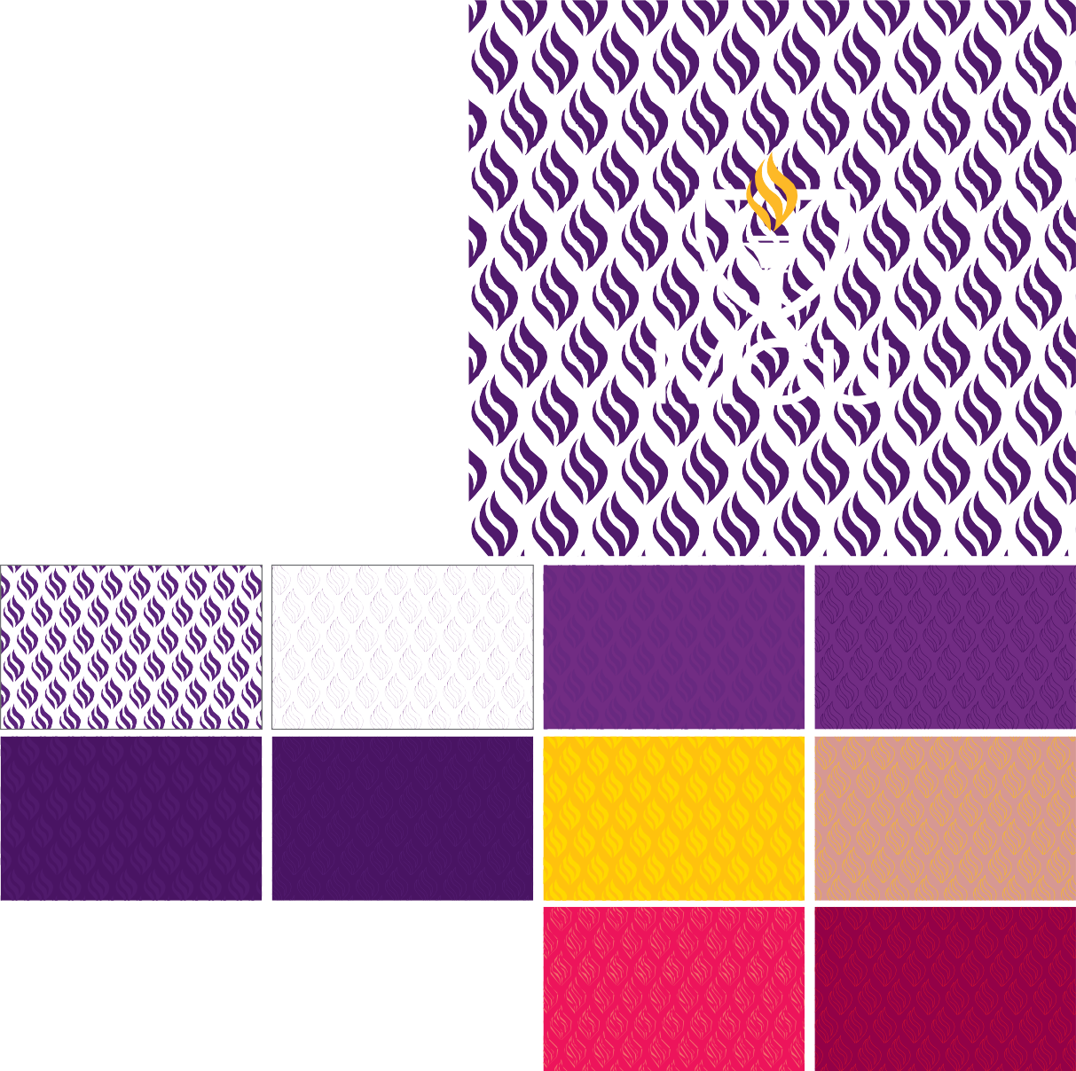

**MCU Flame**

Derived from the both the University Seal and logo.

You may use this pattern as subtle background, texture or for special merchandise.

You may create your own pattern palette using our brand colors.

Always seek approval from our communications and marketing department prior publishing a communication piece.

BRAND PATT ER N

###### Sampaguita Flame

5 torch flames which symbolizes our five (5) core values forming a sampaguita flower.

Always seek approval from our communications and marketing department prior publishing a communication piece.

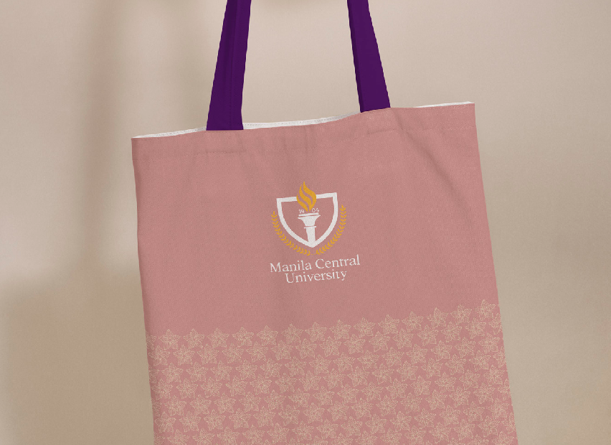





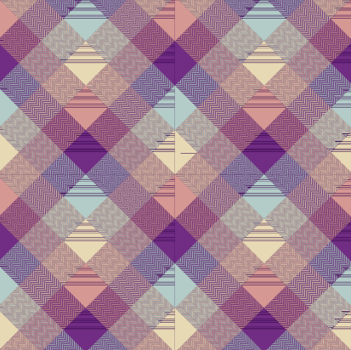BRAND PATT ER N

###### Banig

Expresses our vibrant and diverse community, rich heritage and colorful Story.

The Banig is available in two

(2) versions - Vibrant and Neutral.

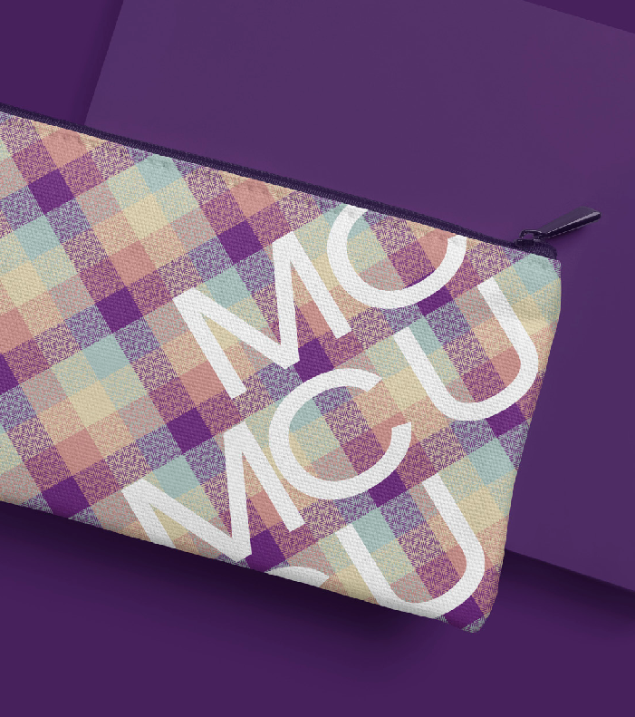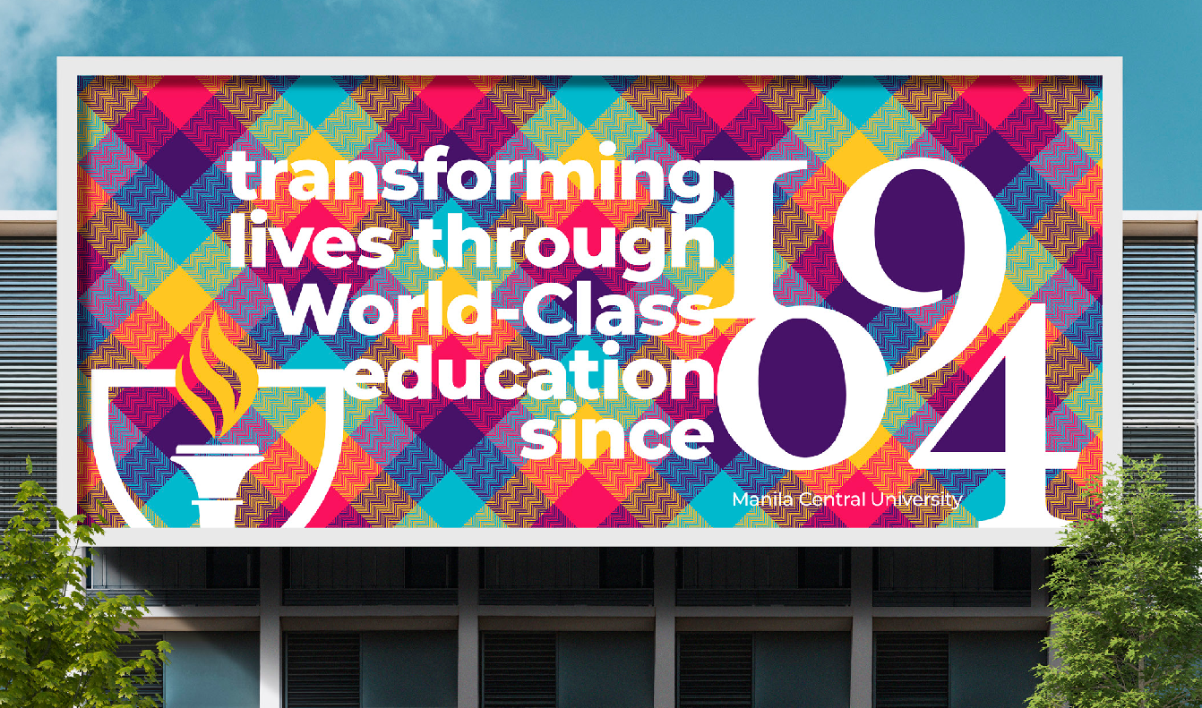

BRAND PATT ER N

###### Rubiks

Similar to the objective of the banig, rubiks is a play of our brand colors which may add impact and accentuate parts of our communication piece.

This pattern may be broken down and use as section dividers, color blocks, etc.



##### Graphic Elements

These elements can be combined with our graphic patterns with the objective of adding visual interest, impact and enhance our communication piece.

Should always be used/applied with caution, our elements should only enhance and should never take away the objective and message of the communication piece.

For clarifications and guidance on the brand usage and applications, or to request a file, please contact our communications department at: [communications@mcu.edu.](mailto:communications@mcu.edu) ph

See sample applications in the succeeding pages.

**62**



GRAPHIC ELEMENT: S AM PLE A PP LIC AT IO N

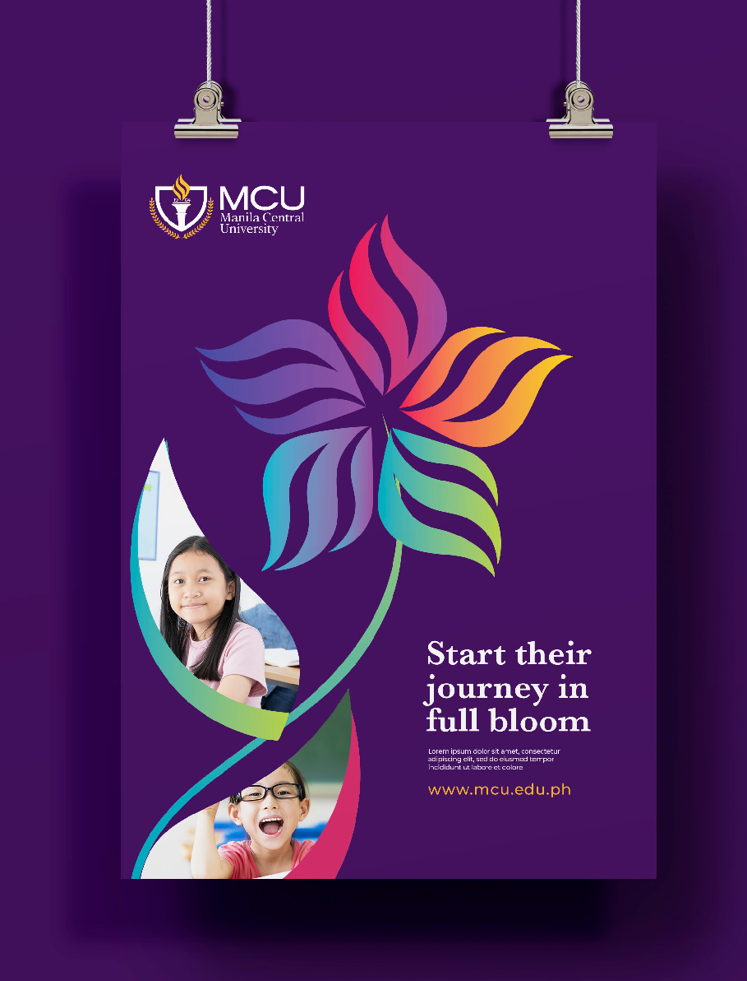

GRAPHIC ELEMENT: S AM PLE A PP LIC AT IO N

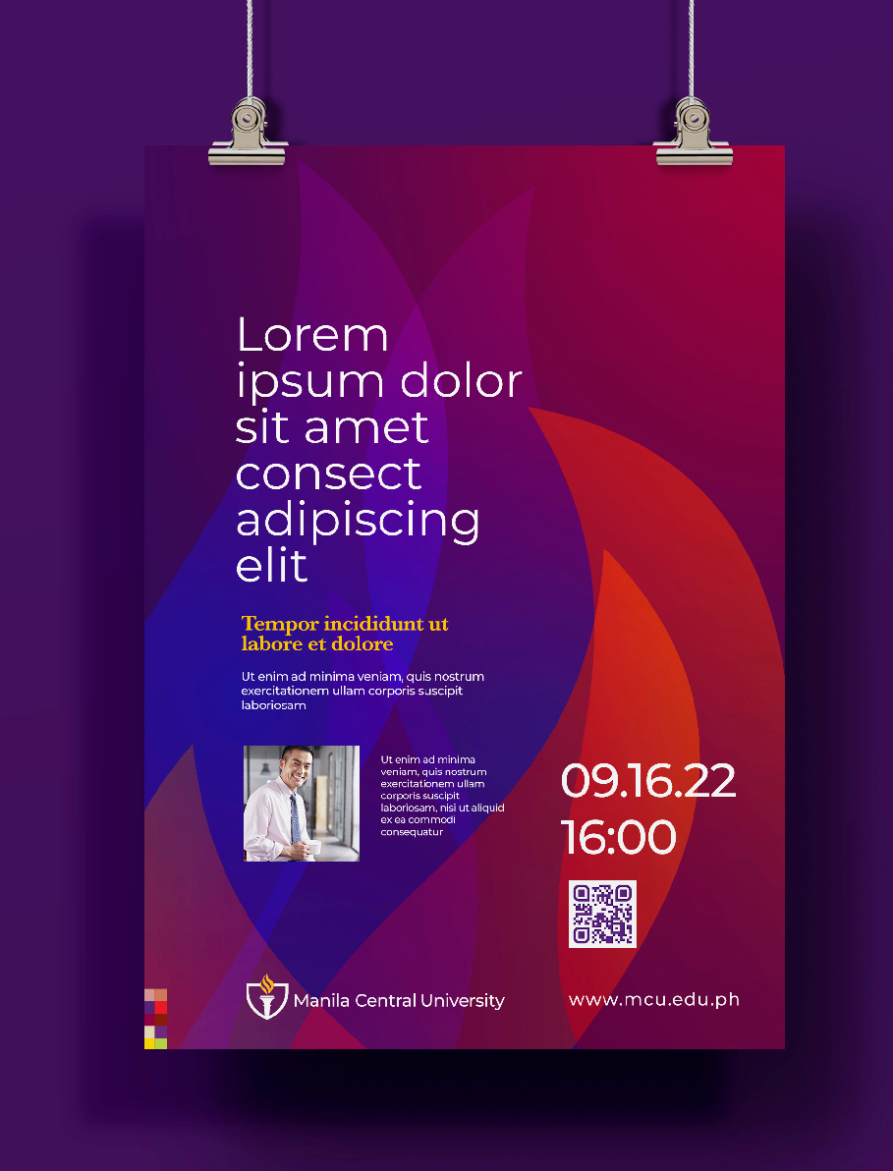

##### Working All Together

We have created simple guidelines and workflow on how best to translate and combine elements to create a compelling and effective MCU communication piece.

Please see sample applications in the next few pages.

Good luck and Keep everything simple, clear yet impactful

##### Application Guidelines

Determine the objective and purpose of your communication. Who are the target audience, what results/communication are you trying to achieve/convey.

1

Choose your key visual element accordingly. If using a photograph, please ensure it follows our style and art direction.

2

Ensure your content and messaging resonates with our personality and tone.

3

Select the proper typography that matches with your content and messaging. Make sure to sectionalize your content layout to aid viewers in determining the most important part of your content down to the trivial detail.

4

Choose the appropriate color palette that matches your tone and manner. Evaluate if you need to add patterns or graphic elements to enhance your communication piece.

5

Make sure the positioning of the seal, logo or other marks are in the right placement and has enough clearspace. Please refer to the guidelines accordingly.

6

Review your work. See to it that the visual look and feel, typography,

7 colors and elements are harmoniously working together. Submit to our marketing and communications department for review and approval

prior publishing.



**65**

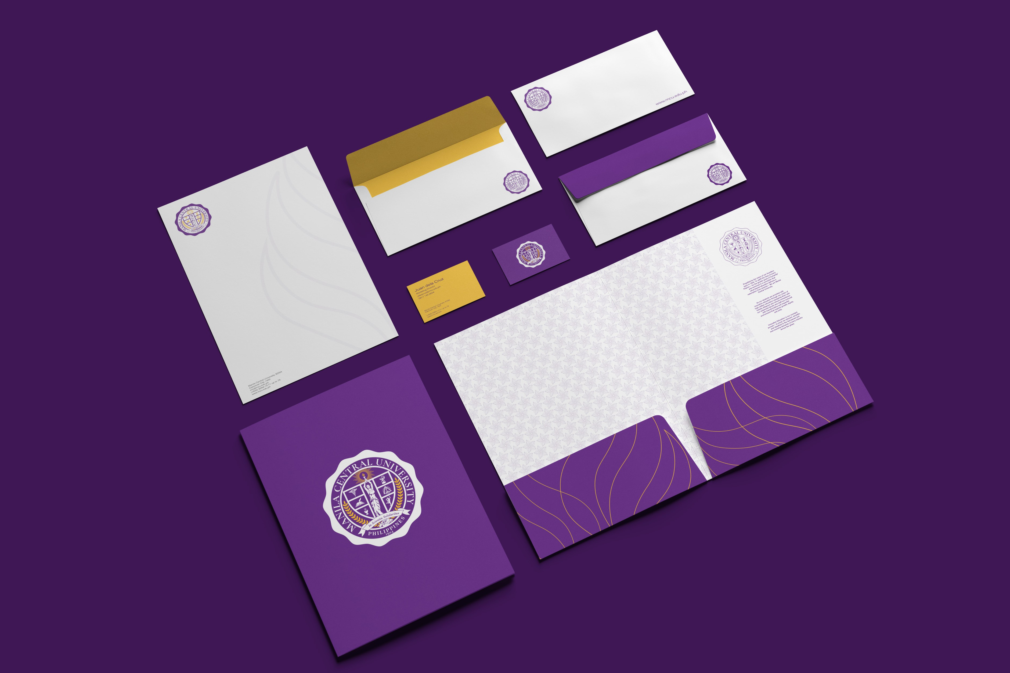

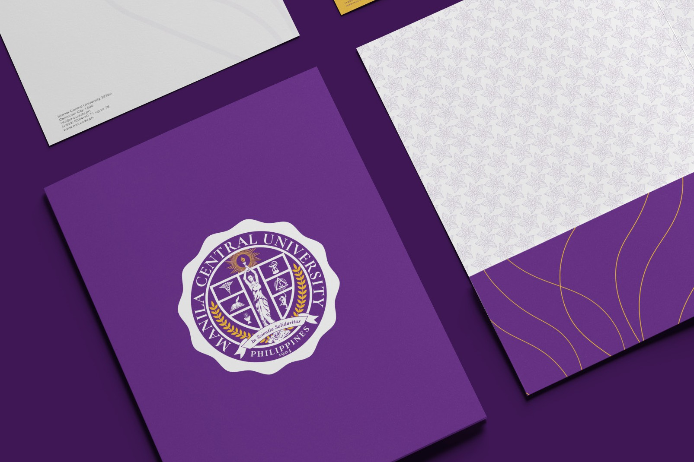

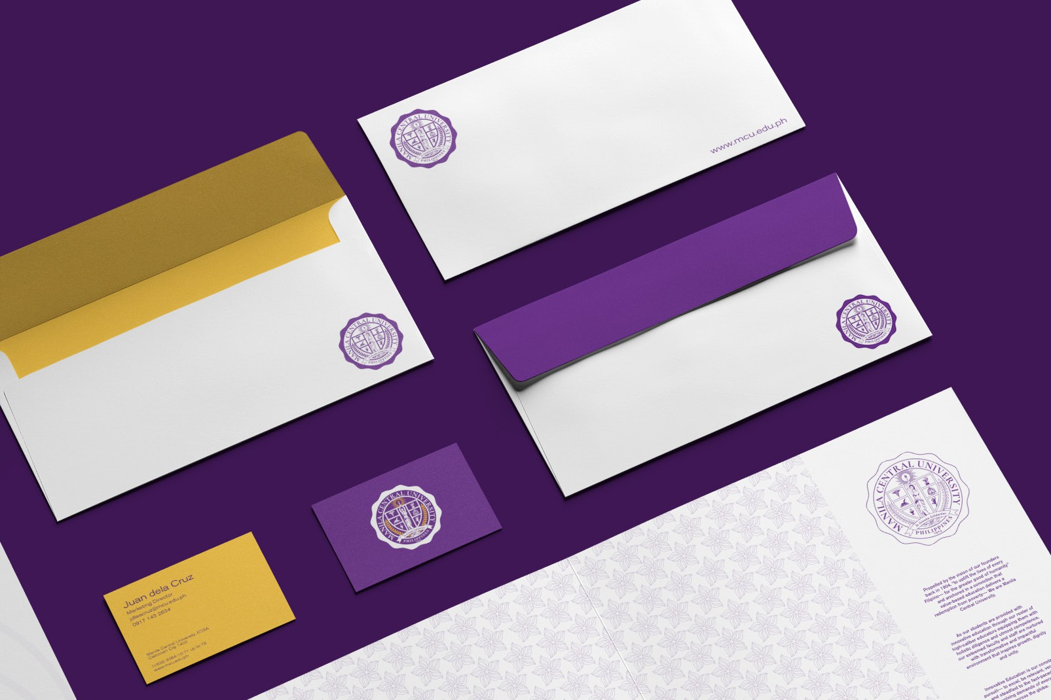

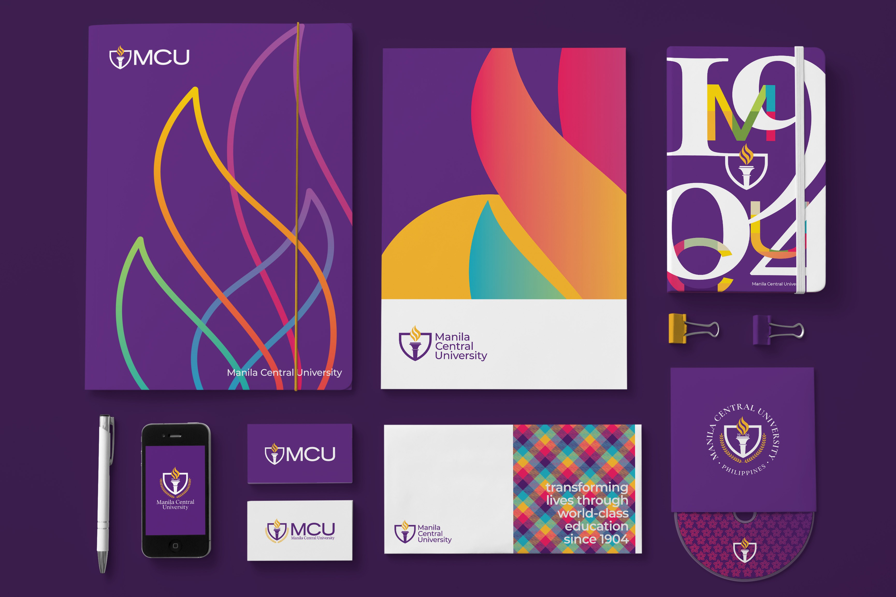







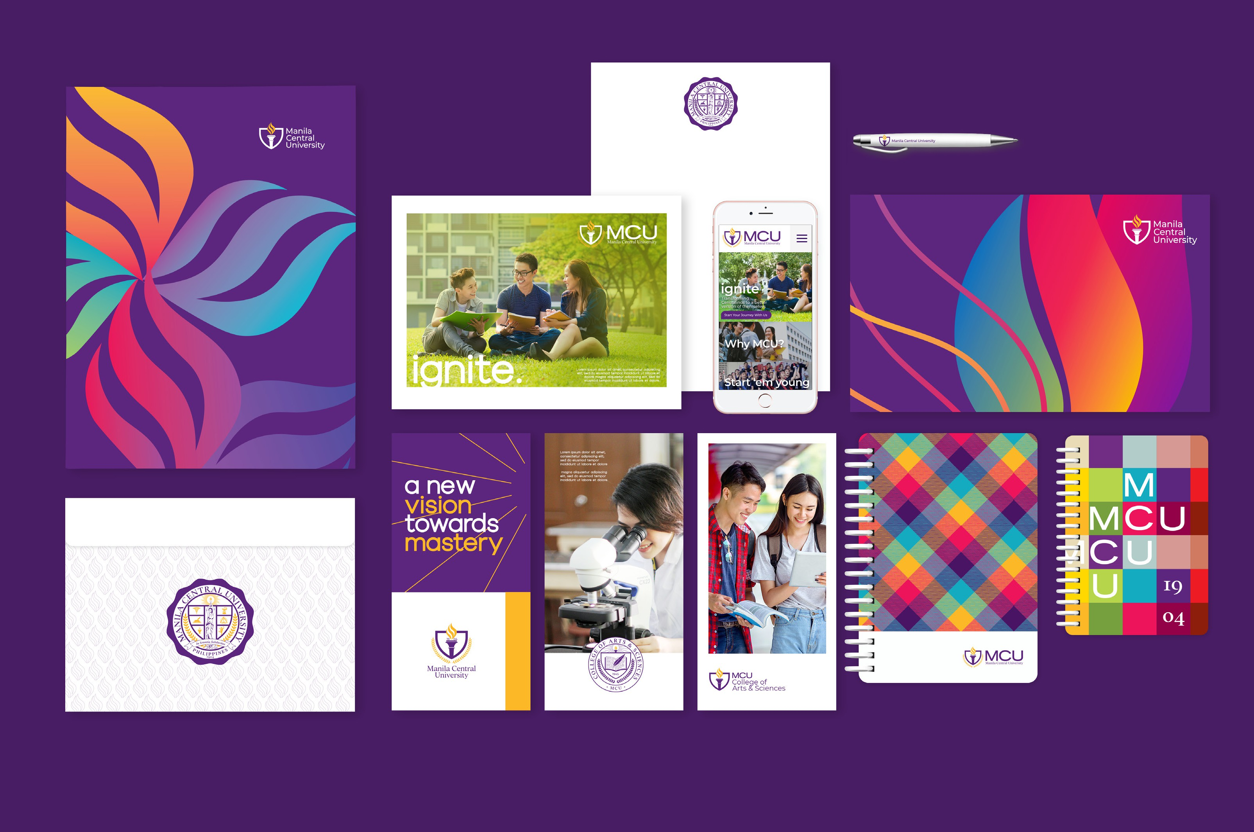





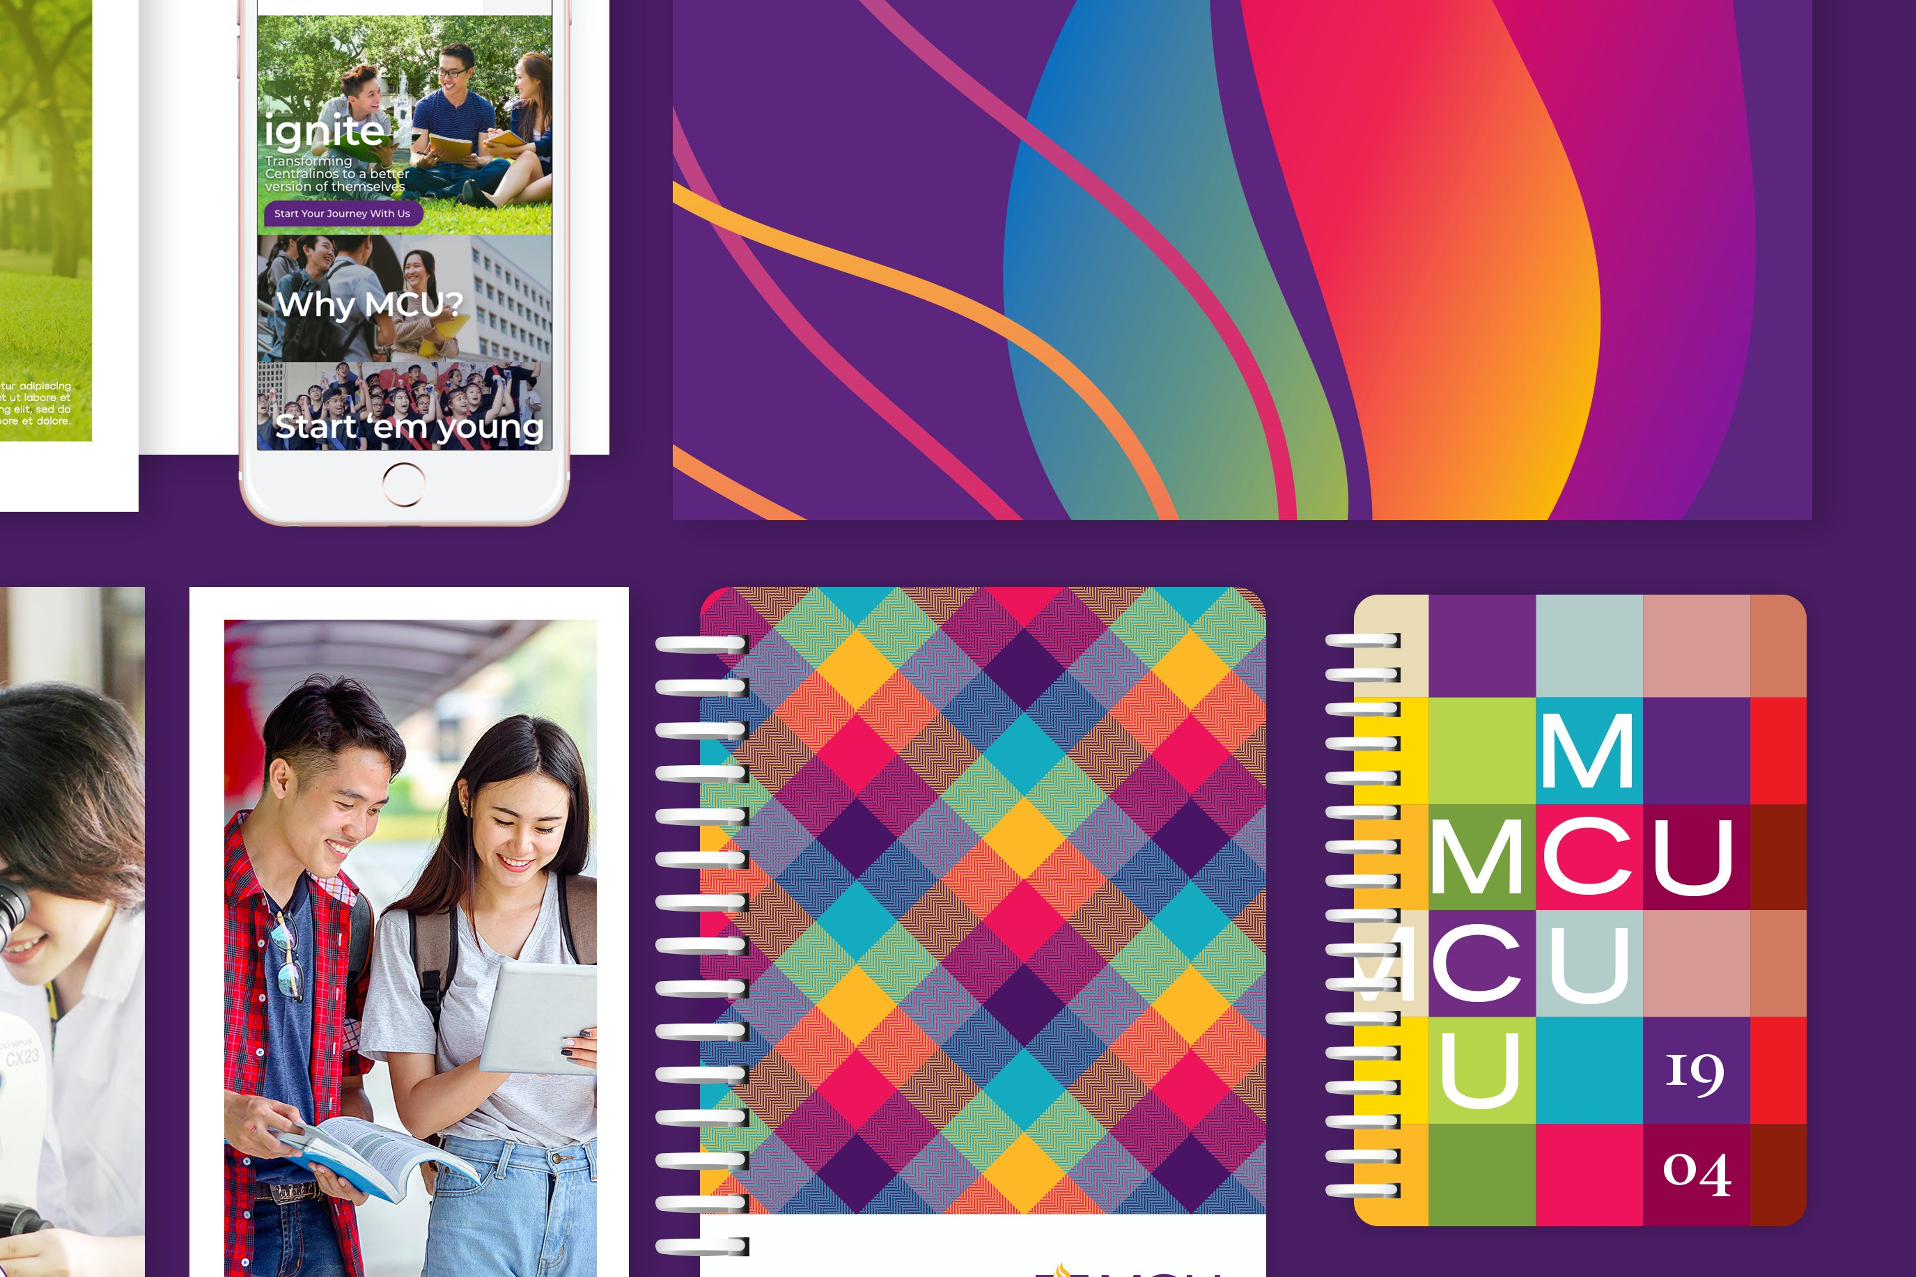

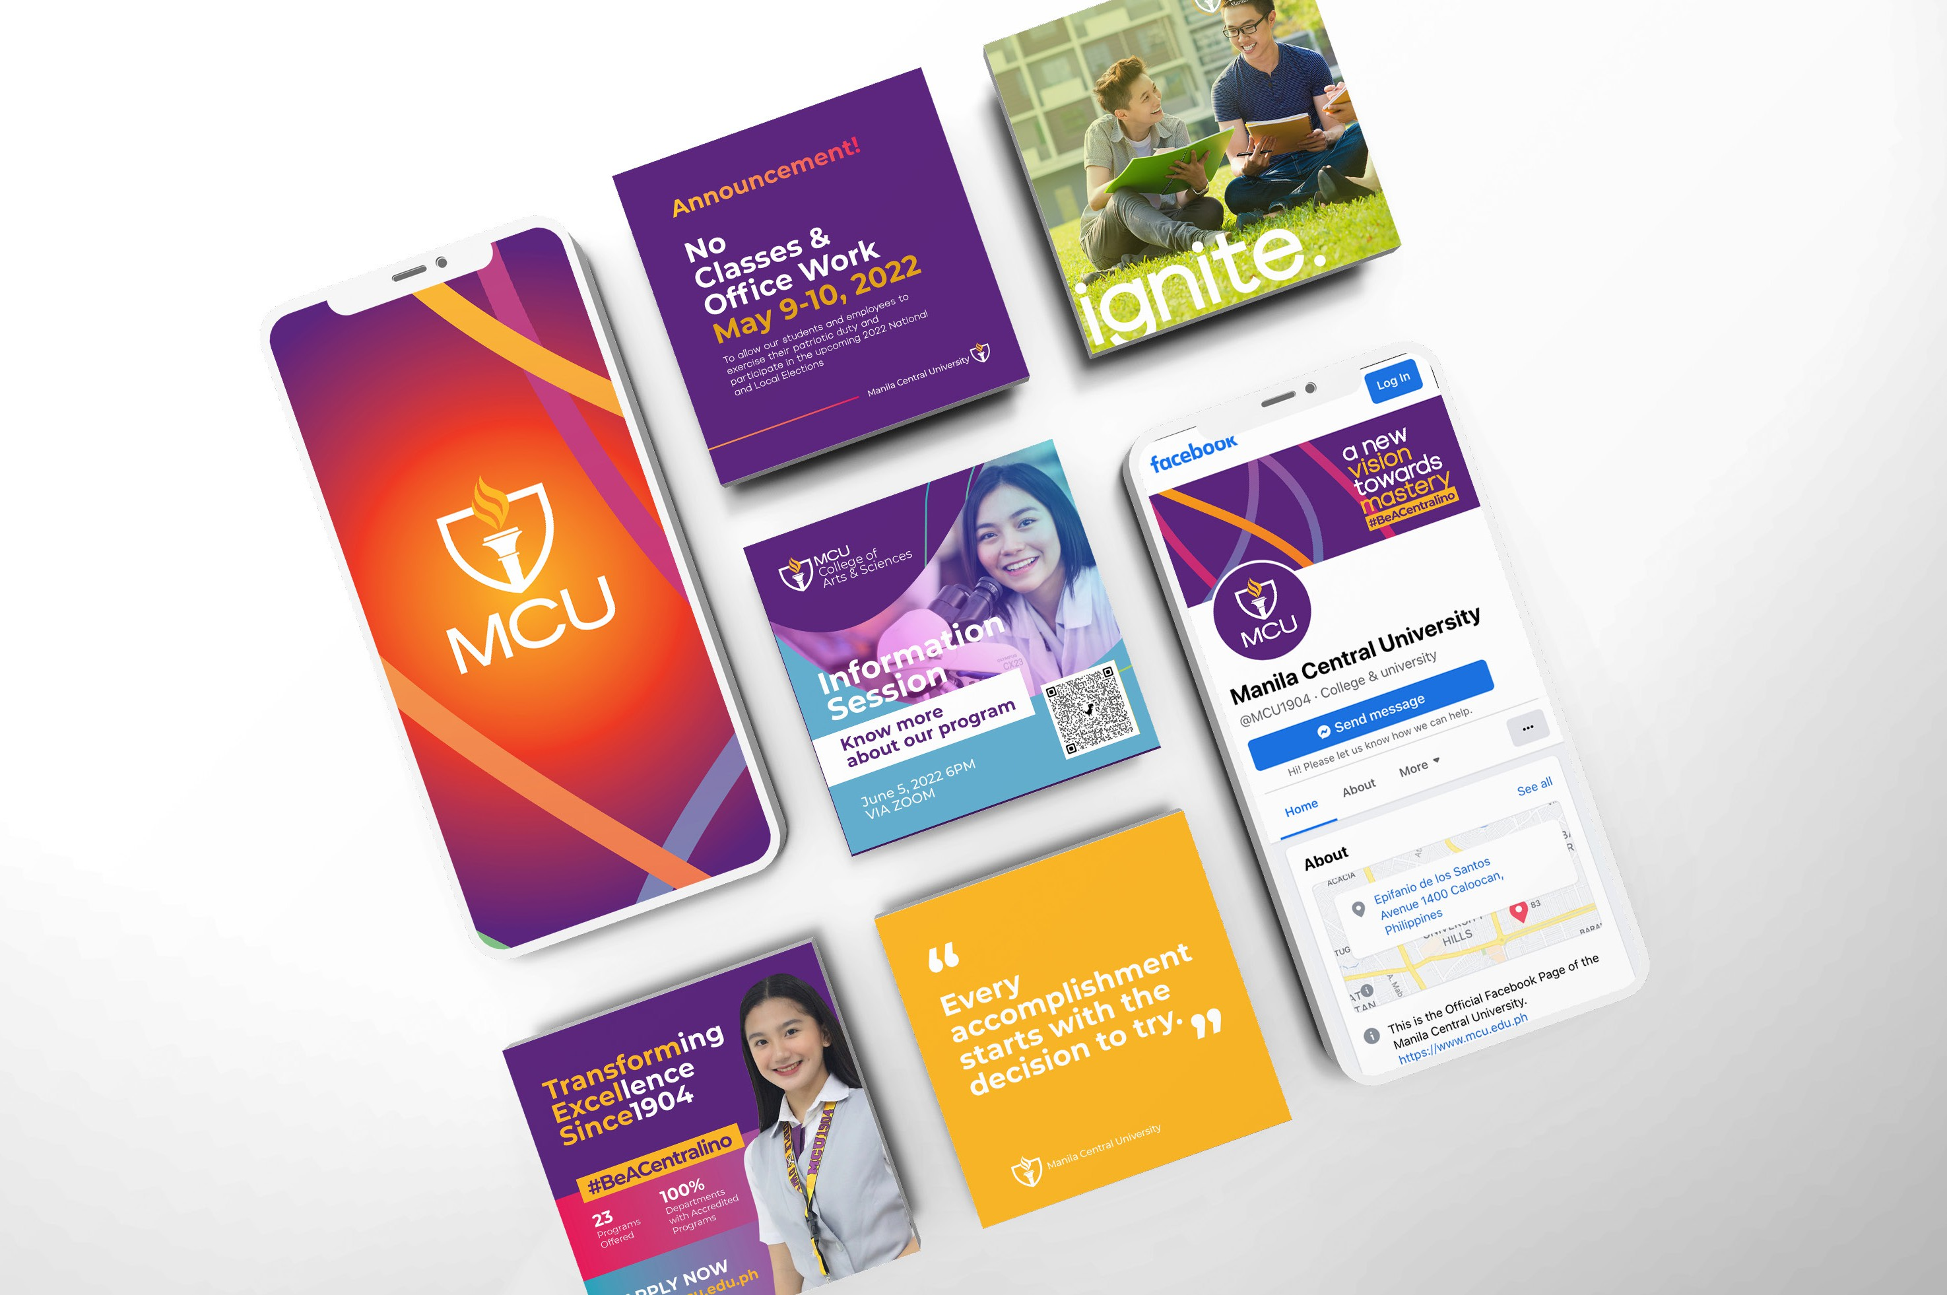

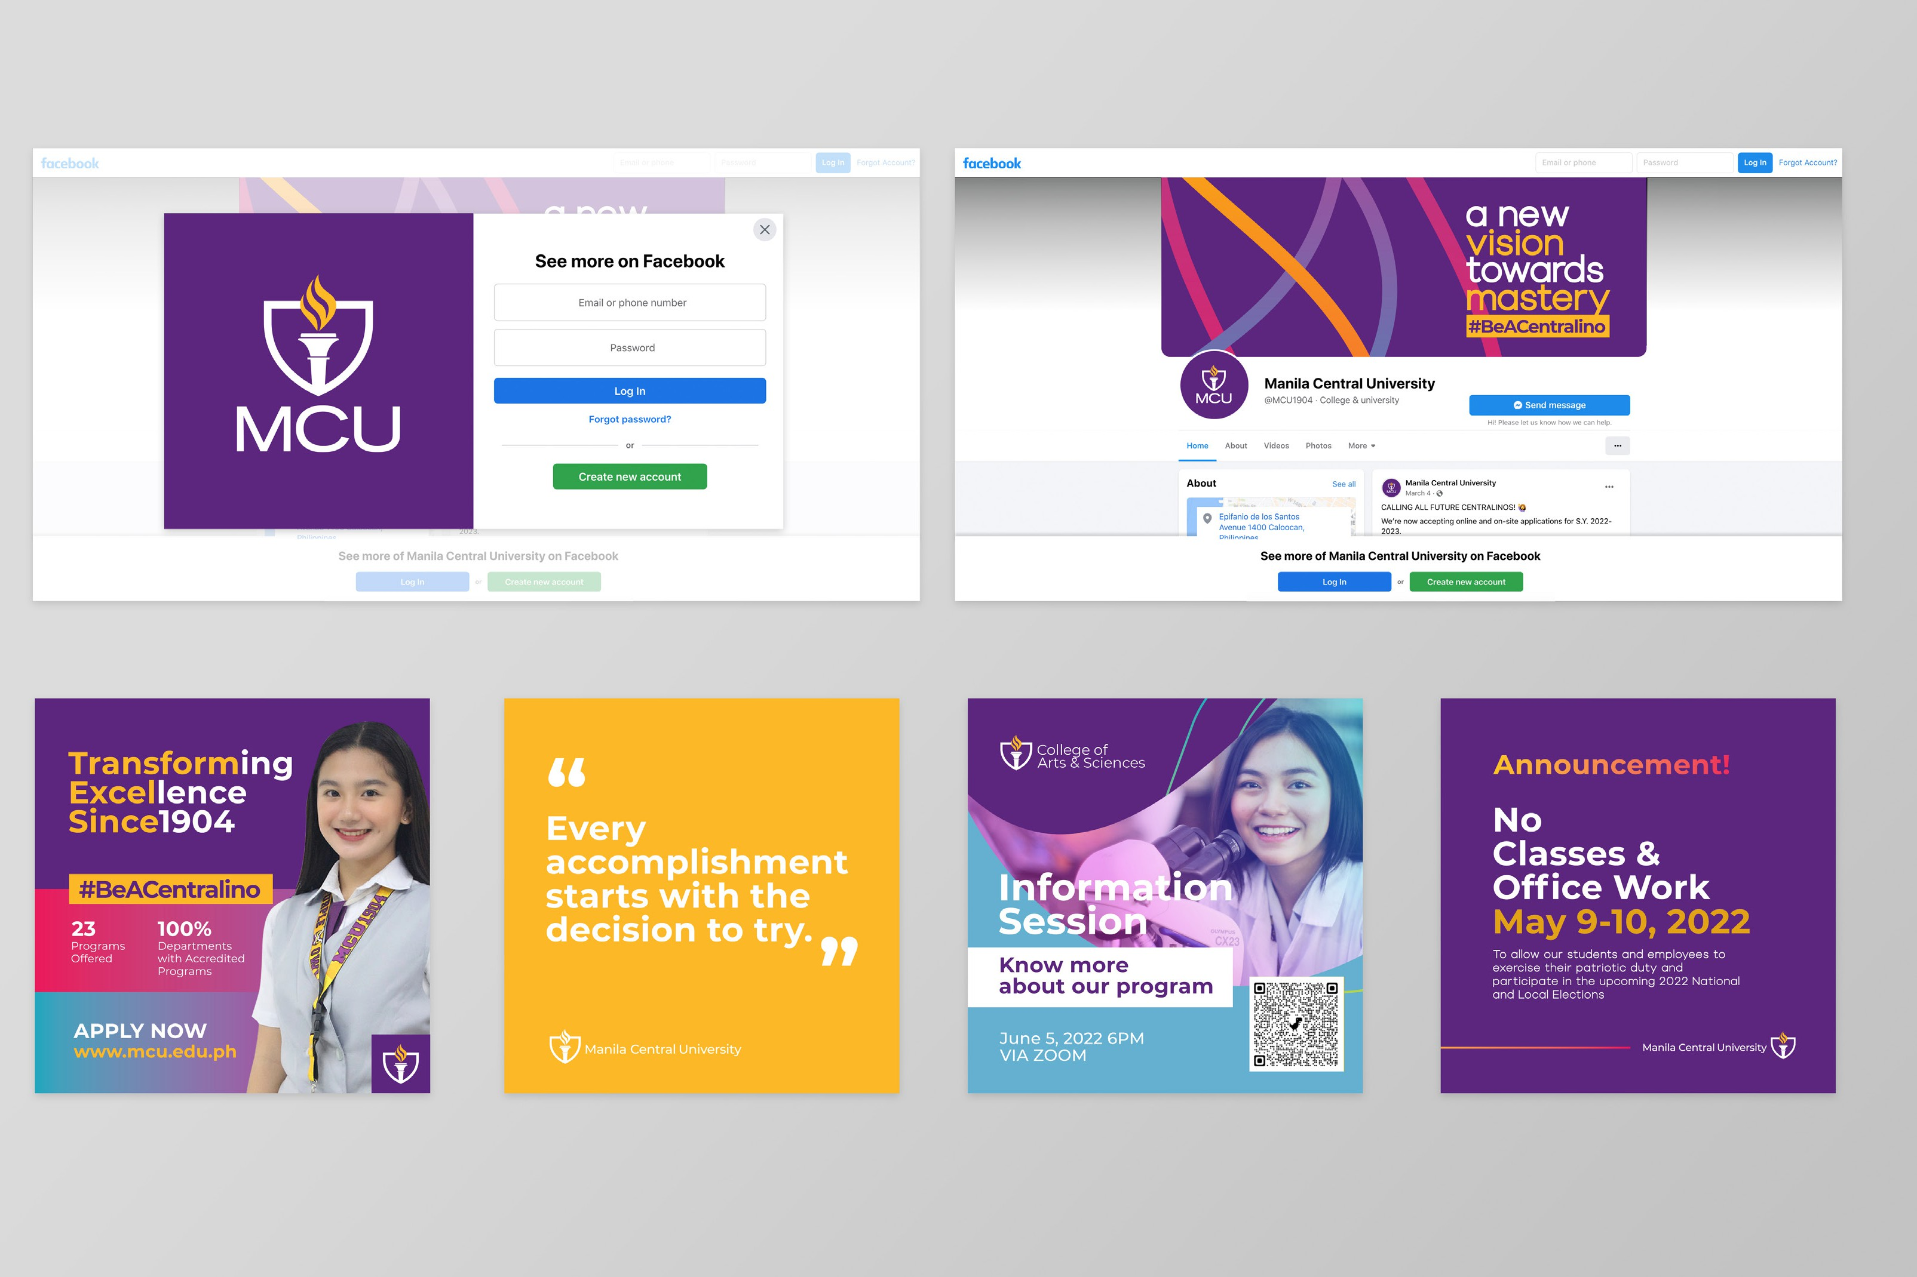

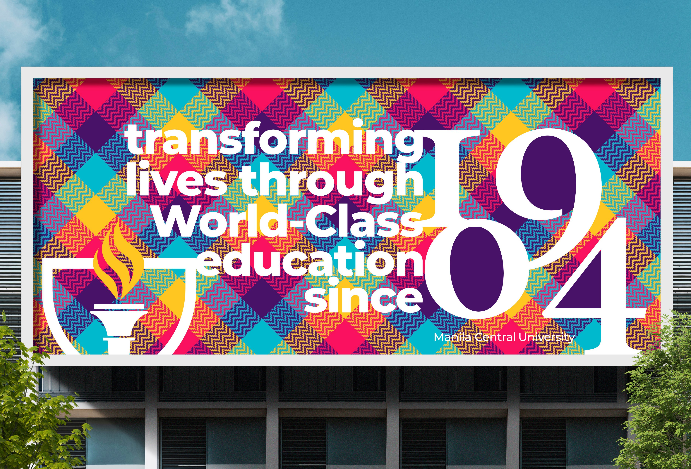



**79**



**80**



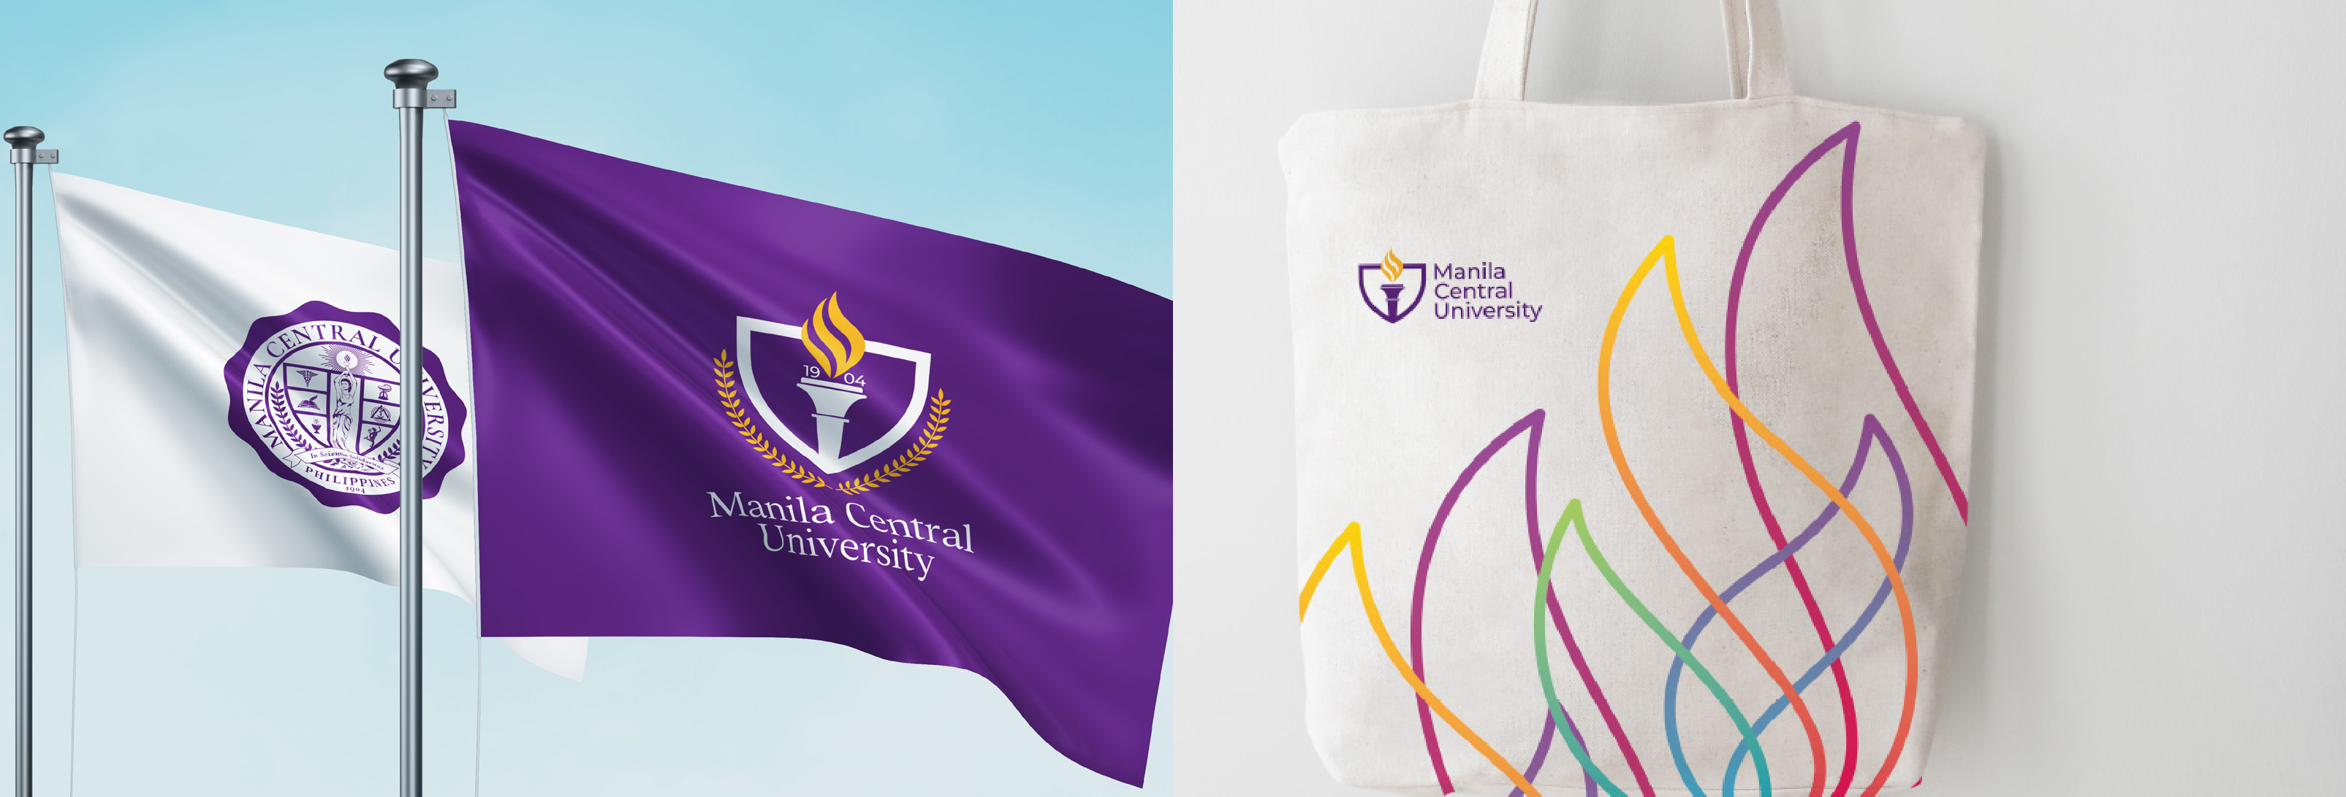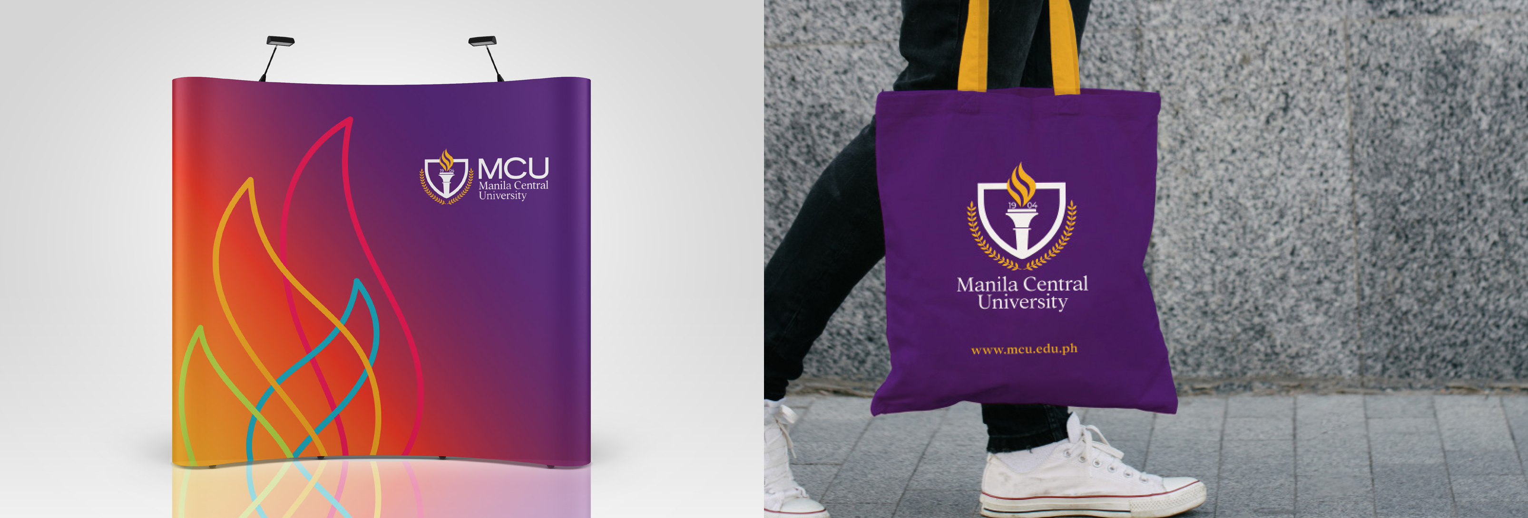



**81**

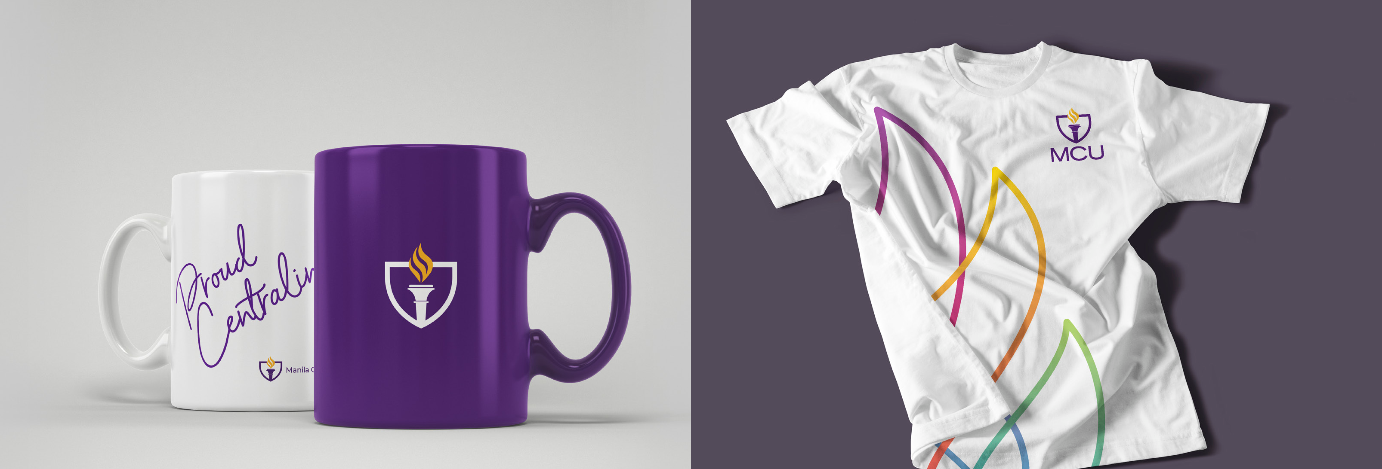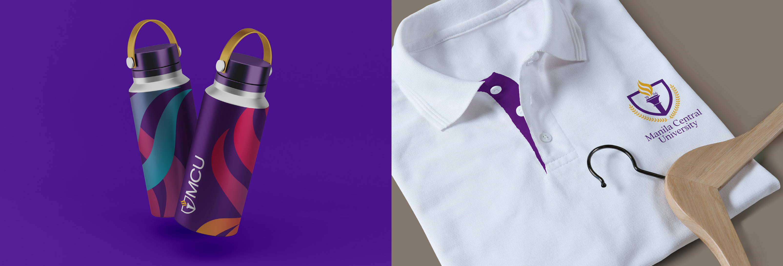

**82**

